

Department of Computer Science
King Abdullah II College of Information Technology
University of Jordan

KHADAMATKOM
(A Platform)

Graduation Project

Supervised by:

Dr. Hazem Alhyari & Dr. Mohammad Al-Otoum

Prepared by:

Majd Basil Saadat | 0211511
Halla Raed Badwan | 0215477
Majd Awni Al- Manaseer | 0213175
Rasmia Shadfan | 0215680

Abstract
In today’s fast-paced world, finding trustworthy part-time service providers can be a challenge for many individuals and families. This graduation project introduces "Khadamatkom", a web-based platform designed to bridge the gap between service seekers and qualified part-time workers across the Kingdom. The platform offers a secure, user-friendly environment that connects users with various service providers, including private tutors, babysitters, housemaids, electricians, and more.
Khadamatkom ensures quality and safety by verifying the identity and reliability of each service provider. The system includes detailed worker profiles, service categories, user ratings, reviews, and image galleries to help clients make informed decisions. The platform also features an admin dashboard for monitoring and management, and a staff section for internal operations.
The project was developed using modern technologies: React, Bootstrap, and CSS for the front-end, and Node.js for the back-end. The platform relies on a secure Postgres database to manage and store user data, service listings, and reviews. The website is fully responsive and supports authentication, user and worker profile editing, and image uploading.
The main goal of Khadamatkom is to create a reliable, scalable solution that promotes digital transformation in the local service economy by offering an organized and safe space for short-term job engagement.

Acknowledgment
First and foremost, I thank Allah for granting me the strength, patience, and perseverance to complete this graduation project successfully.
I would like to express my sincere gratitude to my supervisors, Dr. Hazem Hayari and Mr. Mohammad Al-Otoum, for their continuous guidance, encouragement, and valuable insights throughout the project journey. Their feedback and expertise played a vital role in shaping the direction and quality of this work.
A special thanks goes to my family and friends for their unwavering support, motivation, and understanding during this process. I also extend my appreciation to my teammates and classmates, whose cooperation and dedication made this experience both productive and enjoyable.
Finally, I am thankful to all the faculty members and staff of the Computer Science Department at the University of Jordan for the knowledge, skills, and inspiration they have provided throughout my academic years.

Contents
Abstract 2
Acknowledgment 2
Chapter One: Introduction 7
1.1 Preamble: 7
1.2 Project Motivation: 7
1.3 Project Objectives: 7
1.4 Project Scope: 7
1.5 Project Software and Hardware Requirements: 8
1.6 Project Limitations: 8
1.9 Report Outline: 10
Chapter TWO: Feasibility Study 11
Chapter Three: Related Existing Systems 12
3.0 Related Existing Systems 12
Chapter Four: Project Management Plan 13
4.0 Project Management Plan 13
4.1 Project Organization 13
4.2 Project Planning and Execution 18
4.3 Risk Analysis and Plans 26
4.4 Monitoring, Reporting, and Controlling Mechanisms 27
Chapter Five: System Requirements and Analysis 27
5.0 System Requirements and Analysis 27
5.1 System Stakeholders and Requirements Sources 27
5.1.1 System Stakeholders 28
5.2 User Requirements 29
5.2.1 Overview of User Requirements 29
5.2.2 User Requirements Breakdown 29
5.2.3 Prioritization of User Requirements 30
5.3 Use Case Diagrams 31
5.3.1 Overview of Use Case Diagrams 31
5.3.2 Use Case Diagrams 31
5.3.3 Explanation of Use Case Diagrams 35
5.4 Textual Description for Each Use Case 36
Use Case 1: General Overview (High-Level) 36
Use Case 2: Registered User (Customer) 40
5.5 System Functional Requirement 50
5.5.1 Authentication and Profile Management 50
5.5.2 Service Management and Worker Interaction 51
5.5.3 Commenting and Review System 51
5.5.4 Smart Recommendation System 52
5.5.5 Password Recovery 52
5.5.6 User Interaction and Interface 53
5.5.7 Admin Functions 54
5.6 Non-Functional Requirements 54
5.6.1 Performance Requirements 54
5.6.2 Reliability Requirements 55
5.6.3 Security Requirements 55
5.6.4 Usability Requirements 55
5.6.5 Compatibility Requirements 55
5.6.6 Maintainability Requirements 56
5.6.7 Legal and Compliance Requirements 56
Chapter six: sYSTEM dESIGN 62
6.2 Context Diagram 62
6.5 UML Use Case Diagrams 66
6.7 UML Class Diagram 79
6.8 Database Design 80
Chapter SEVEN: SYSTEM TESTING AND INSTALLATION 84
Chapter eight: pROJECT CONCLUSIONS AND FUTURE WORK 91
8.0 PROJECT CONCLUSIONS AND FUTURE WORK 91
8.1 Introduction 91
8.2 Overall Weaknesses 91
8.3 Overall Strengths 92
8.4 Future Work 92

Table of Figures
Figure 1: Project Schedule 10
Figure 2: Agile Development Methodology 18
Figure 3 agile life cycle 19
Figure 4: Project Schedule Gantt Chart 25
Figure 5: Project Schedule PERT Diagram 25
Figure 6: General Overview Use case diagrams 33
Figure 7:Use case diagrams for Registered User (Customer) 34
Figure 8: Use case diagrams for Worker 34
Figure 9: Admin Use Case Diagram 35
Figure 10: Internal System Use Case Diagram 35
Figure 11 : Context Diagram 63
Figure 12:Data Flow Diagrams 64
Figure 13: Entity Relationship Diagram 65
Figure 14: UML use case diagram 66
Figure 15: UML use case diagram 2.1 67
Figure 16:UML use case diagram 2.2 68
Figure 17: UML use case diagram 2.3 68
Figure 18:Sequence Diagram 1 : Login 69
Figure 19: Sequence Diagram 2: registering new account 69
Figure 20 : Sequence Diagram 3: cancel booking 70
Figure 21: Sequence Diagram 4: access homepage 70
Figure 22 : Sequence Diagram 5: book a service 71
Figure 23 : Sequence Diagram 6: submit a review 71
Figure 24 : Sequence Diagram 7: edit profile 72
Figure 25 : Sequence Diagram 8: view booking history 72
Figure 26 : Sequence Diagram 9: manage a service 73
Figure 27 : Sequence Diagram 10: view received booking 73
Figure 28 : Sequence Diagram 11: accept or reject a service 74
Figure 29: Sequence Diagram 12: edit a service provider profile 74
Figure 30 : Sequence Diagram 13: book another service provider 75
Figure 31 : Sequence Diagram 14: admin login with role check 75
Figure 32 : Sequence Diagram 15: view all users 76
Figure 33 : Sequence Diagram 16: view all service provider 76
Figure 34 : Sequence Diagram 17: view all reviews 77
Figure 35 : Sequence Diagram 18: delete a review 77
Figure 36 : Sequence Diagram 19: view all booking 78
Figure 37 : Sequence Diagram 20: manage booking 78
Figure 38 : UML Class Diagram 79
Figure 39 : Database Design 80
Figure 40 : Prototype for Home Page 80
Figure 41 : prototype for Register 81
Figure 42 : Prototype for Login Page 81
Figure 43 : Prototype For Services page 82
Figure 44: Profile and Profile editing 82

Figure 45 : request Figure 46: Services 83
Figure 47: Prototype Admin dashboard 83

Chapter One: Introduction

Preamble:
In today’s fast-paced world, individuals often struggle to find reliable and skilled part-time workers for various household and personal tasks. The process of locating qualified professionals for services such as private tutoring, house painting, babysitting, and domestic help is frequently time-consuming, uncertain, and lacks proper quality assurance. Additionally, there is no unified or trusted system that streamlines this process, making it difficult for people to access the services they need with confidence.

Project Motivation:

- Increasing demand for part-time and on-demand services (e.g., tutoring, home maintenance, childcare).
- Lack of a centralized and trusted platform to connect clients with service providers.
- Need to support skilled individuals in Jordan seeking flexible job opportunities.
- Challenges related to trust, quality, and verification in informal service hiring.
- Desire to enhance local employment and contribute to Jordan’s economic and digital development

Project Objectives:

The main objective of the project is to develop a user-friendly web platform, KHADAMATKOM, to connect individuals with qualified part-time service providers, ensuring quality and convenience, through:

- Create a Centralized Platform.
- Ensure Quality and Reliability.
- Facilitate Easy Booking.
- Enable Secure Transactions.
- Support Local Employment.

Project Scope:
This project involves the design and development of a web-based platform that facilitates the exchange of services between clients and providers within Jordan. The platform will include essential features such as:
- Service and job listings with detailed descriptions.
- User registration and profile management for clients and workers.
- Basic provider profiles to build trust and credibility.
The system will cater to multiple user types, including individuals seeking services, freelancers offering their expertise, and organizations looking to hire part-time help

Project Software and Hardware Requirements:

Frontend:
-Languages: HTML, CSS, JavaScript.
-Frameworks/Libraries: React.

Backend:
-Languages: Node.js.
-Frameworks: Express (for Node.js).

Database:
-Database Systems: Postgres.

Additional Tools:
- Version Control: Git and GitHub.
- Design and Prototyping: Canva.

Project Limitations:

- Description: Ensuring robust data protection with limited resources may be challenging.
- Compatibility Challenges: ensuring KHADAMATKOM compatibility with various operating systems, browsers, and devices can be challenging.
- An internet connection to access the portal all the time.
- Difficulty in finding professionals and craftsmen in some areas.
- Dealing with a specific category of craftsmen who may charge us specific prices.

  - Project Expected Output:

The KHADAMATKOM project is expected to deliver a fully functional and user-friendly web platform that connects service seekers with qualified part-time providers. The key expected outputs include:
- A responsive website accessible via desktop.
- User registration and authentication system for clients and workers.
- Service listing.
- A dashboard for managing requests, offers, and profiles.
- A basic rating and review system to ensure service quality.
- Full project documentation covering analysis, design, implementation, and testing

  - Project Schedule:

Project management is the discipline of planning, organizing, securing, and managing resources to achieve specific goals. Table (1) illustrates the time schedule of implementing the project.

Table 1: Project Schedule
Task | Task | Description | Start time | End Time | Duration | Dependency
T1 | Planning | Define golas,scope,and timeline | 24/7/2024 | 27/7/2024 | 4 Days | -
T2 | Information Gathering | Collect functional and non-functional requirements | 28/7/2024 | 5/8/2024 | 8 Days | T1
T3 | Analysis | Analyze requirements and define system specifications | 6/8/2024 | 11/8/2024 | 5Days | T2
T4 | Design | Design UI/UX, database schema, and architecture | 22/2/2025 | 15/3/2025 | 23 Days | T3
T5 | Development | Develop frontend and backend modules | 16/3/2025 | 15/5/2025 | 59 Days | T4
T6 | Testing & Debugging | Perform system testing and fix bugs | 16/5/2025 | 22/5/2025 | 6 Days | T5
T7 | Documentation | Write full report and technical documentation | 22/5/2025 | 25/5/2025 | 3 Days | T1,T2,T3,T4,T5
T8 | Final Presentation | Prepare slides and rehearse presentation | 19/5/2025 | 22/5/2025 | 3 Days | T6.T7
T9 | Submission | Submit final report and present the project | 23/5/2025 | 23/5/2023 | 1 Days | T8

Figure 1: Project Schedule

1.9 Report Outline:

The report is organized into eight main chapters:
- Chapter 1: Introduction – Covers the project motivation, problem statement, objectives, scope, expected outputs, limitations, and timeline.
- Chapter 2: Feasibility Study – Evaluates the technical, operational, economic, and legal feasibility of the system.
- Chapter 3: Existing Systems – Reviews current solutions and highlights gaps that KHADAMATKOM aims to address.
- Chapter 4: Project Management Plan – Details the organizational structure, development approach, schedule, risks, and management processes.
- Chapter 5: System Requirements & Analysis – Describes stakeholder needs, system functionality, use cases, and requirements.
- Chapter 6: System Design – Provides system architecture, diagrams, database design, and prototypes.
- Chapter 7: Testing & Installation – Outlines testing methods, installation steps, and user manual content.
- Chapter 8: Conclusion & Future Work – Summarizes the project's strengths, limitations, and potential future enhancements.

Chapter TWO: Feasibility Study

This chapter evaluates the feasibility of the KHADAMATKOM platform from various perspectives to ensure successful implementation.

2.1 Technical Feasibility
Assesses whether the required technologies are available, reliable, and suitable for system development.
- 2.1.1 Technology Stack and Their Roles
The system will be built using modern technologies such as React (frontend), NodeJS (backend), and Postgres (database). Each technology is chosen for its scalability, support, and performance.
- 2.1.2 Scalability and Future-Proofing
The system is designed to scale both horizontally and vertically, ensuring it can support future feature expansion and increased user traffic.
- 2.1.3 Security Considerations
In the future, the platform will implement secure authentication, data encryption, and protection against common vulnerabilities (e.g., SQL injection, XSS).
- 2.1.4 Testing and Validation
System modules will be tested using unit, integration, and user acceptance testing to ensure functionality and reliability.
- 2.1.5 Contingency Planning
Backup mechanisms and error-handling strategies will be implemented to recover from failures and minimize downtime.

2.2 Operational Feasibility
The system is practical to use and manage, with an intuitive interface for users and administrative tools for backend management.

2.3 Economic Feasibility
The platform can be developed and maintained within a reasonable budget using open-source tools and cloud hosting services.

2.4 Legal Feasibility
All operations will comply with Jordanian laws regarding data privacy, employment, and electronic transactions.

Chapter Three: Related Existing Systems

3.0 Related Existing Systems

This chapter explores existing platforms that offer similar service-marketplace functionality to KHADAMATKOM, highlighting their strengths and weaknesses as a basis for improvement.

3.1 Overview of Existing Systems
Globally, there are platforms such as Task Rabbit, Up work, and Care.com that connect service providers with clients. These platforms specialize in freelance work, domestic services, and personal care.

3.2 Problems of Existing Systems
- Most platforms are not tailored to the local Jordanian market.
- Many services are limited to specific categories or require complex verification.
- Language and cultural differences may affect usability.
- Payment systems may not support local currencies or methods.

3.3 Proposed Solutions in the New System
KHADAMATKOM aims to overcome these issues by offering a locally focused platform with English language support, simple onboarding, flexible service categories.

Chapter Four: Project Management Plan

4.0 Project Management Plan
This chapter outlines how the KHADAMATKOM project was managed from start to finish, covering team roles, planning, development methodology, scheduling, risk analysis, and monitoring strategies.

4.1 Project Organization

Our project will be organized to achieve the highest efficiency with minimal costs, ensuring all goals are met within the timeline. The tasks will be distributed among team members based on their strengths, but collaboration and knowledge sharing will be key to maximizing each member’s learning experience. The following sections will outline the project structure, deliverables, and the analytical studies that will guide our work.

4.1.1 Roles and Responsibilities

- Project Manager:
  - Responsibilities: The Project Manager will be responsible for setting the overall project schedule, ensuring tasks are distributed appropriately, and maintaining the project within the allocated budget. The Project Manager will also monitor progress, organize regular team meetings, manage risks, and communicate with stakeholders (e.g., university advisors).
  - Key Tasks:
    - Create and maintain the project plan.
    - Facilitate communication among team members.
    - Track project milestones and deliverables.
    - Identify and mitigate risks.

- Software Leader:
  - Responsibilities: The Software Leader will define the technical and functional architecture of the system, ensure code quality through reviews, and oversee the integration of software components. They will also be responsible for conducting feasibility studies related to software implementation and ensuring that all code meets the project’s standards.

  - Key Tasks:
    - Define coding standards and architecture.
    - Oversee version control and code management.
    - Review and approve code before integration.
    - Conduct software feasibility studies.
- Developer:
  - Responsibilities: The Developer is responsible for the coding, testing, and implementation of the software. They will work closely with the Software Leader to ensure that the code is functional, efficient, and meets the project requirements. The Developer will also assist in troubleshooting and debugging as needed.
  - Key Tasks:
    - Write and test code according to project specifications.
    - Integrate software components and ensure functionality.
    - Collaborate with the Designer on GUI implementation.
    - Perform debugging and optimize performance.

- Designer:
  - Responsibilities: The Designer is responsible for creating the visual design and user interface (UI) of the system. They will develop prototypes and design the graphical user interface (GUI), ensuring it is user-friendly and aligns with the project’s overall objectives. The Designer will also work closely with the Developer to implement the design effectively.
  - Key Tasks:
    - Create wireframes, prototypes, and final UI designs.
    - Design the graphical user interface (GUI).
    - Ensure design consistency across all screens and elements.
    - Collaborate with the Developer for design implementation.

- Quality Assurance (QA):
  - Responsibilities: Although not a separate role, Quality Assurance will be a shared responsibility among all team members. The team will focus on ensuring that the system functions as expected, is free of bugs, and meets the project’s quality standards before final delivery.
  - Key Tasks:
    - Conduct unit and integration testing.
    - Review code for potential issues.
    - Perform user acceptance testing (UAT).
    - Document and track issues and fixes.

4.1.2 Project Governance

- Decision-Making Structure
  - Project Manager: The Project Manager holds the primary decision-making authority on day-to-day operations, task allocation, and issue resolution. They will make decisions based on input from the team and ensure alignment with the project goals. The Project Manager is also responsible for escalating any critical issues or decisions to the university advisors when necessary.
  - Consensus-Based Decisions: For significant decisions that impact the overall direction of the project, such as changes to the project scope, timeline adjustments, or major design changes, decisions will be made based on a consensus among the Project Manager, Software Leader, and other key team members. This collaborative approach ensures that all perspectives are considered before making critical decisions.
  - Stakeholder Involvement: University advisors and other stakeholders will be consulted on major decisions that could impact the final project deliverables or overall success. Their input will be sought during key milestones, and their feedback will be incorporated into the project as needed.

- Reporting and Communication
  - Regular Team Meetings: Weekly team meetings will be scheduled to review progress, address any issues, and plan for the upcoming week. These meetings will be led by the Project Manager and will provide a forum for team members to discuss their progress, share challenges, and collaborate on solutions.
  - Progress Reports: The Project Manager will prepare bi-weekly progress reports to keep the team and stakeholders informed about the project's status. These reports will include updates on completed tasks, upcoming milestones, risk assessments, and any changes to the project plan.
  - Stakeholder Updates: Regular updates will be provided to university advisors and other stakeholders at key milestones, such as the completion of major phases (e.g., design, development, testing). These updates will include summaries of progress, challenges encountered, and any proposed changes to the project plan.
- Quality Assurance
  - Quality Standards: The project will adhere to predefined quality standards to ensure that all deliverables meet the expected level of excellence. These standards will be established at the beginning of the project and will guide all aspects of the work, from coding practices to design elements.
  - Continuous Review: Quality Assurance (QA) will be a continuous process throughout the project, with regular code reviews, design evaluations, and testing to ensure that the project meets its quality standards. The QA process will involve all team members and will be integrated into the daily workflow.
  - Final Review and Approval: Before the final delivery, the project will undergo a thorough review by the entire team, with input from university advisors as needed. The final deliverable will be approved by the Project Manager and other key team members to ensure that it meets all project requirements and quality standards.
- Documentation and Handover
  - Documentation: Throughout the project, the Project Manager will ensure that all work is properly documented, including meeting minutes, decision logs, risk assessments, and progress reports. This documentation will be maintained in a shared repository accessible to all team members.
  - Handover Process: At the conclusion of the project, all documentation, code, designs, and other deliverables will be compiled and handed over to the university advisors or any other designated stakeholders. A final project report will be prepared, summarizing the project’s achievements, lessons learned, and any recommendations for future work.

4.2 Project Planning and Execution

4.2.1 Software Process Model
The type of software process model used is The Agile Model. The reason is that our system’s requirements are clear and understandable, it is better for management, and we will not have many changes. See Figure 1: Agile Development Methodology
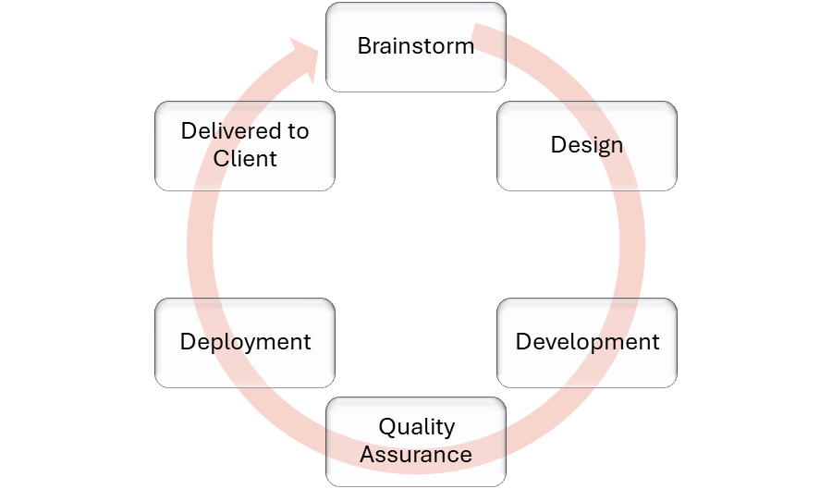
Figure 2: Agile Development Methodology

4.2.2 Breakdown

Project Tasks. See Figure 2: Project Tasks
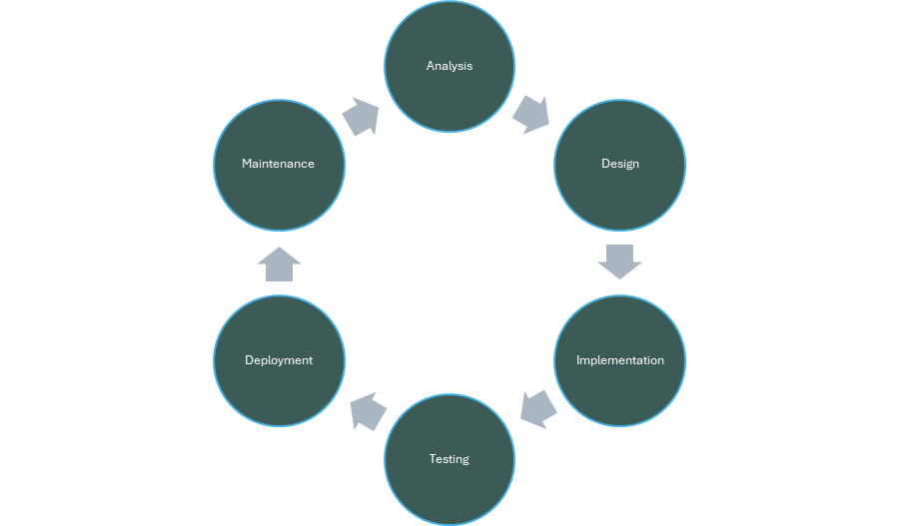
Figure 3 agile life cycle

Table 2: Task Description
Phase | Task | Description | Duration
Analysis | Task1 | Gather user requirements | 3 Days
 | Task2 | Define objectives | 3 Days
 | Task3 | Conduct feasibility study | 4 Days
 | Task4 | Gather System requirements | 1 Days
Design | Task5 | Design user interface | 12 Days
 | Task6 | Design database schema | 3 Days
 | Task7 | Design system functionalities | 5 Days
Implementation and Testing | Task8 | Develop and test system components | 30 Days
 | Task9 | Test the system with the users | 7 Days
 | Task10 | Train users and stakeholders | 4 Days
 | Task11 | Deploy the system | 1 Days

Table 3: Deliverables and Milestones
**** | Phase | Milestone | Deliverable | Due Date
Milestone 1 | Project kickoff planning | Project kickoff meeting | Requirements document | 24/07/2024
 |  | Requirements review | Project plan
Milestone 2 | Design and development | Design Review | User Interface Designs | 22/02/2024
 |  | Functional Specification Review | Functional Specifications
Milestone 3 | Testing and Deployment | Acceptance Testing | Test cases | 17/05/2024
 |  | Production Deployment | User Documentation
Milestone 4 | Maintenance and Support | Periodic Maintenance Release | Feature Enhancements | Not specific
 |  |  | Bug fixes

Resources Needed (Skills, HW and SW):
- Planning
  - Vision & Mission
  - Strategizing
  - Goals & Objectives
- Organizing
  - Organization Design
  - Culture
  - Social Network
- Leading
  - Leadership
  - Decision Making
  - Communication
  - Groups and Teams
  - Motivation
- Controlling
  - System Processes
  - Strategic Human Resources

Table 4:Hardware and Software
**** | Description | Quantity | Unit Price (JD) | Total Price
HD1 | Laptop | 4 | 600 JD | 2,400 JD
SW1 | PostgresSQL(Open Source) | 1 | Free | Free
HD2 | Web Hosting | 1 | 50JD | 50 JD
SW2 | Domain Name | 1 | 20JD | 20JD
SW3 | System Update | 1 | 500JD | 500JD
HD3 | UI\UX Tools ( Figma , Free Plan) | 1 | Free | Free

ID | Description | Duration Time | Dependencies | Skills Required | Hardware | Software
T1 | Requirement Gathering | 5 Days | None | Communication, Interviewing | Laptop/PC | Google Forms, MS Word
T2 | Project Planning and Structuring | 5 Days | T1 | Agile Planning, Time Management | Laptop/PC | SmartDraw, Trello
T3 | Feasibility Study | 3 Days | T1,T2 | Analytical Thinking | Laptop/PC | MS Word, Excel
T4 | Risk Analysis | 3 Days | T2 | Risk Management | Laptop/PC | MS Word
T5 | Software Requirement Specification (SRS) | 7 Days | T1,T2 | Documentation, Analysis | Laptop/PC | MS Word
T6 | System Analysis | 4 Days | T3,T5 | System Modeling | Laptop/PC | Lucid
T7 | System Design | 10 Days | T5,T6 | UI/UX Design, Architecture Planning | Laptop/PC | DB Designer, Figma
T8 | Database Design | 8 Days | T5,T7 | Relational Modeling | Laptop/PC | DB Designer, PostgreSQL
T9 | GUI Design | 30 Days | T7 | UI/UX Design | Laptop/PC | Figma, VS Code
T10 | System Implementation (Frontend + API) | 20 Days | T8,T9 | Programming, Problem-Solving | Laptop/PC | VS code , React , NodeJS
T11 | Testing and Debugging | 4 Days | T10 | QA Testing, Debugging | Laptop/PC | VS Code
T12 | Final Presentation & Reporting | 7 Days | ALL previous | Presentation, Writing | Laptop/PC | PowerPoint, MS Word
Table 5: Dependencies and Constraints

Constraints:
- The software produced must be secure and easy to use.
- Team members must meet up to follow up on everything planned.
- All team members must hand out their tasks in the required time.

4.2.3 Assigning Team Members to Tasks

Table 6:Assigning Team Members to Tasks
Member | Tasks
Majd Saadat | Task 2: Define the scope and objectives
 | Task 3: Conduct feasibility study
 | Task 5: Design user interface
Majd Al-Manaseer | Task 5: Design user interface
 | Task 7: Design system features and functionality
 | Task 1: Gather user requirements
Hala Badwan | Task 6: Design database schema
 | Task 7: Gather Software Requirements
 | Task 8: Develop and test system components
Rasmia Shadfan | Task 9: preparing complex test cases
 | Task 10: Test the system
 | Task 11: Deploy the system

4.2.4 Project Schedule

Figure 4: Project Schedule Gantt Chart
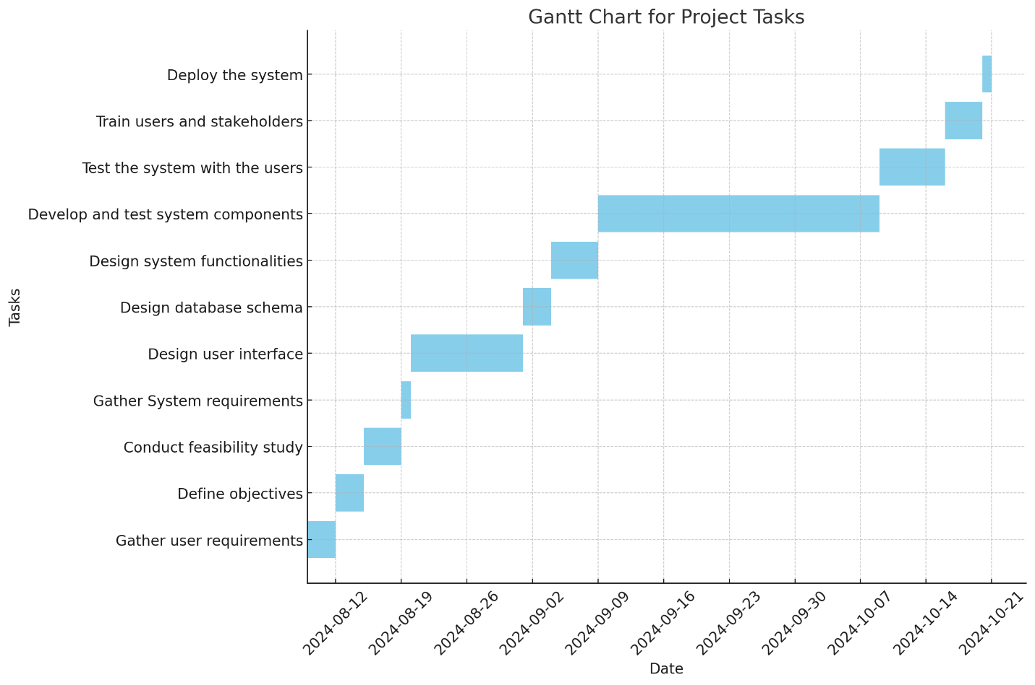
23/7 28/7 2/8 6/8 22/2 2/3 12/3 20/3 1/5 10/5 15/5 20/5

The project starts on February 25 th and is scheduled to be completed on May 21st. The project schedule includes 11 tasks dependent on each other in a sequential order. And below you will find the project schedule represented in a PERT Diagram. See Figure 4: Project Schedule PERT Diagram
Figure 5: Project Schedule PERT Diagram
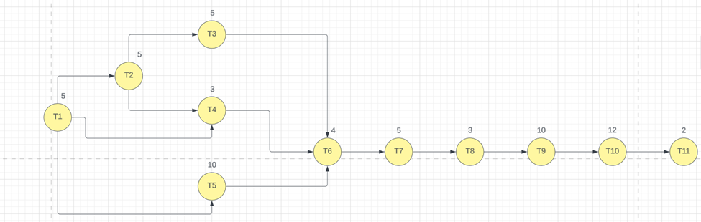
From the previous schedule, we conclude that:
The critical path: T1, T2, T5, T6, T7, T8, T9, T10, T11 = 64.
So, if the critical path is less than the deadline then the project schedule is feasible.
//Note: There are 12 days (about 1 week 5 days) not compatible with project delivery

4.3 Risk Analysis and Plans

4.3.1 Risk Analysis

Table 7:Risk Analysis
Possible Risk | Effects | Probability | Description
Hardware unavailability | project | Low | The hardware that is essential for the project will not be delivered on schedule.
Management change | project | Low | There will be a change of organizational management with different priorities.
Staff turnover | project | Moderate | Team members may leave or be unavailable during key phases of development
Low productivity | project | Moderate | Task delays due to exams, personal issues, or technical blockers may slow progress
Internet instability | Technical | Moderate | Poor or unstable internet could affect collaboration, code sharing, or deployment.

4.3.2 Risk Plans
Table 8:Risk Plans
Possible Risk | Dealing with risk
Hardware unavailability | Project managers will order the hardware needed as early as possible from the distributors they always deal with and rely on.
Management change | Project managers will discuss the importance of the project with its details with the new managers.
Staff turnover | The team will be reorganized so that there is overlap in tasks between members to facilitate covering tasks in the event of absence.
Low productivity | Clear objectives will be set within the project plan and mitigation will be made in the case of student exams.
Internet instability | A contingency plan includes working offline, providing alternative points of contact, or working from stable locations.

4.4 Monitoring, Reporting, and Controlling Mechanisms
The methods we used to monitor, report, and control the progress of the KHADAMATKOM project are as follows:
- Addressing a Real Community Need:
KHADAMATKOM addresses a pressing need within the local Jordanian community by providing a structured digital platform that connects service seekers with part-time service providers, enhancing accessibility and transparency in the informal job market.
- Innovative and User-Centered Solution:
The platform offers an innovative and user-friendly web-based solution that leverages modern technologies to simplify service discovery, booking, and interaction between clients and workers in various fields like tutoring, domestic help, and maintenance.
- Potential for Social and Economic Impact:
KHADAMATKOM contributes to economic development by opening new work opportunities for freelancers and skilled individuals while also improving the quality and convenience of everyday services for clients.
- Community Empowerment and Inclusion:
The platform fosters collaboration and inclusion by empowering individuals from different social and professional backgrounds to participate in the local digital economy, promoting fairness and trust between users.
- Scalability and Adaptability:
The system has been designed with scalability in mind, allowing for future expansion in features, user base, and service categories. It can also adapt to the evolving needs of the local community through modular and flexible architecture.
- Feedback and Continuous Improvement:
Built-in feedback mechanisms (e.g., service ratings, user reviews, reporting features) enable continuous improvement. Regular updates will be made based on user suggestions, ensuring the platform remains relevant, reliable, and aligned with user expectations.

Chapter Five: System Requirements and Analysis

5.0 System Requirements and Analysis

5.1 System Stakeholders and Requirements Sources

In this section, we identify the key stakeholders involved in the system and outline the sources from which the system requirements were gathered. Understanding the stakeholders and accurately capturing their requirements is crucial for the successful development of the system.

5.1.1 System Stakeholders

The following are the primary stakeholders involved in the project:
• Users (Customers):
Role: Primary service requesters and consumers.
Interests:
-Browse and discover available services easily.
-View and compare service providers (workers).
-Book services and track their status.
-Rate and review workers after service completion.
• Workers (Service Providers):
Role: Providers of various services listed on the platform.
Interests:
-Create and manage service profiles.
-Receive and manage service requests.
-Communicate with users effectively.
-Get feedback and ratings to improve visibility and trust.
• Admin (System Administrator):
Role: Oversees and manages the platform’s operations.
Interests:
-Monitor user and worker activities.
-Manage platform content and categories.
-Resolve disputes and ensure policy compliance.
-Generate reports and maintain system security.
-View user and worker account information and the ability to delete an account
-View comments and delete unwanted comments

5.2 User Requirements

In this section, we outline the specific needs and expectations of the end-users who will interact with the system. The user requirements capture what the system must do from the perspective of those who will be using it daily, ensuring that the final product meets their needs effectively.

5.2.1 Overview of User Requirements

The user requirements were gathered through a combination of interviews, surveys, and workshops . These requirements reflect the functionalities and features that users expect from the system to enhance their experience and improve operational efficiency.

5.2.2 User Requirements Breakdown

1. User (Customer)
General Requirement:
Users need to browse, request, and review services and service providers easily.
Requirement:
The system must allow users to register/login, browse available services, filter by category or location, view worker profiles, send service requests, rate workers, and leave feedback after service completion.
Purpose:
To help users find trusted service providers quickly and ensure a smooth and transparent service experience.

2. Worker (Service Provider)
General Requirement:
Workers need to manage their profiles and respond to service requests efficiently.
Requirement:
The system must allow workers to register/login, create and update their service profiles, receive and accept/reject service requests, communicate with users, and view feedback and ratings.
Purpose:
To enable workers to promote their skills, manage job opportunities, and build a reputation through user ratings and reviews.

3. Admin (System Administrator)
General Requirement:
Admins need to monitor platform activities and ensure the system runs smoothly and securely.
Requirement:
The system must allow admins to manage user and worker accounts, approve or suspend service listings, resolve reported issues, oversee communications, and generate analytical reports.
Purpose:
To maintain system integrity, enforce policies, and ensure a safe and efficient environment for all stakeholders.

5.2.3 Prioritization of User Requirements
The user requirements for the Khadamatkom system have been prioritized based on their significance to user satisfaction, platform usability, operational efficiency, and data security. The prioritization helps guide development efforts and ensures that the most critical features are implemented first.
High Priority:
- User and worker registration/login
- Browsing and requesting services
- Worker profile management
- Rating and reviewing.
- Admin monitoring and system security

Medium Priority:
- Tracking service requests
- Basic admin analytics

Low Priority:
- Custom dashboards
- Advanced filters
- In-app payments (future phase)

5.3 Use Case Diagrams
Use case diagrams are essential in analyzing and designing the Khadamatkom system. They provide a clear visual representation of the interactions between different users (actors) — such as users, workers, and admins — and the system itself. These diagrams help illustrate the key functionalities offered by the platform and how each stakeholder interacts with them.

5.3.1 Overview of Use Case Diagrams
The following use case diagrams illustrate the main interactions between the Khadamatkom system and its users. Each diagram focuses on a specific user type—User, Worker, or Admin—and shows how the system supports their key tasks and requirements. These diagrams help visualize how the system meets the needs of all stakeholders.

5.3.2 Use Case Diagrams
Use Case Diagram 1: General Overview Diagram (High-Level)
Description:
This diagram includes all key actors and their main interactions with the Khadamatkom system.
Actors:
- Guest User
- Registered User (Customer)
- Worker
- Admin
Use Cases:
- Register / Login / Logout
- View homepage
- Browse services
- View service details
- Send service request
- View worker profile
- Rate and review a worker
- Contact support
- Reset password

Use Case Diagram 2: Registered User (Customer) Use Case Diagram
Use Cases:
- Register and login
- Browse and search for services
- Filter services by category or location
- View detailed worker profiles
- Send service requests
- Rate and review workers
- Update personal profile
- Reset password

Use Case Diagram 3: Worker Use Case Diagram
Use Cases:
- Register and login
- Create/edit service profile
- View and manage incoming requests
- Accept or reject requests
- Communicate with users
- View reviews and ratings
- Reset password

Use Case Diagram 4: Admin Use Case Diagram
Use Cases:
- Manage users and workers
- Monitor system activity
- View system reports
- Remove inappropriate content

Use Case Diagram 5: System Internal Use Case Diagram (Optional/Future Enhancements)
Use Cases:
- Handle user authentication
- Store and retrieve service data
- Process and store reviews
- Generate recommendations (future)
- Send notifications

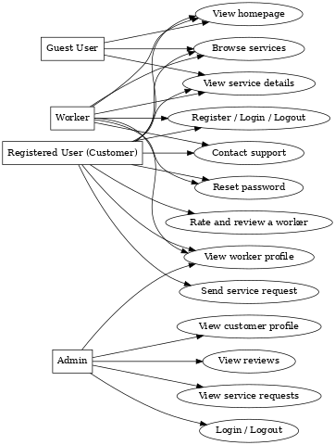
Figure 6: General Overview Use case diagrams

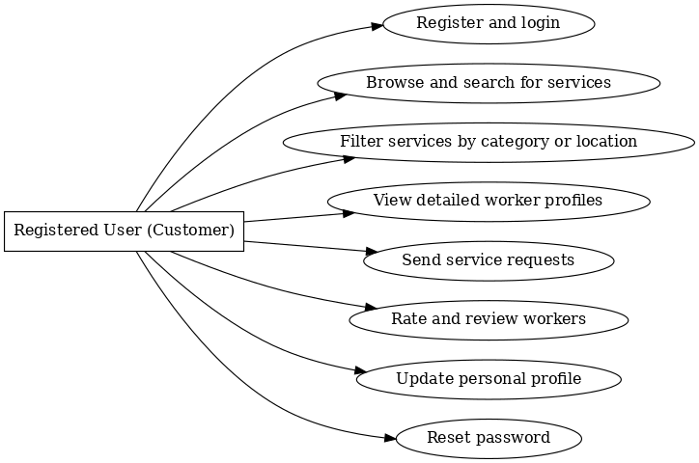
Figure 7:Use case diagrams for Registered User (Customer)
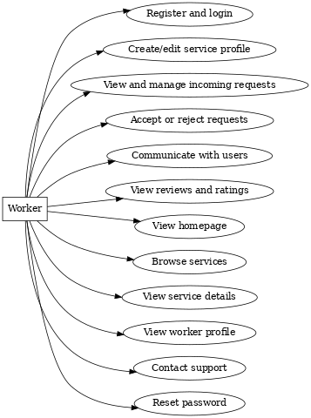
Figure 8: Use case diagrams for Worker

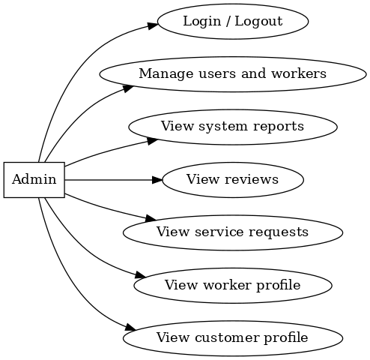
Figure 9: Admin Use Case Diagram
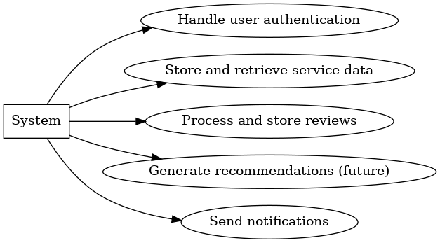
Figure 10: Internal System Use Case Diagram

5.3.3 Explanation of Use Case Diagrams
The single use case diagram included in this document provides a high-level overview of the main interactions between the different users—customers, workers, and admins—and the Khadamatkom system. It summarizes the essential system functionalities accessed by each user group and serves as a foundational reference for the development process, ensuring clarity in how each feature should behave.

5.4 Textual Description for Each Use Case

Use Case 1: General Overview (High-Level)
1.Register
Preconditions :
The user is not logged in and is on the registration page.

Main Flow of Events :
- The user fills out the registration form with required fields ( name, email, password, role).
- The system validates the input for format and required fields.
- A new user or worker account is created in the system database.
- The user is redirected to the login page.

Postconditions:
A new user or worker account is created and stored in the database.

2.Login
Preconditions:
The user has already registered and has valid credentials.

Main Flow of Events:

- The user enters their email and password.

- The system validates the credentials.

- If valid, a new session is initiated.

- The user is redirected to their respective dashboard (customer or worker).

Postconditions:
The user is logged in with an active session.

3.Logout
Preconditions:
The user is logged in with an active session.

Main Flow of Events:

- The user clicks the logout button.

- The session is terminated.

- The user is redirected to the homepage.

Postconditions:
The user is logged out and the session is cleared.

4. View Homepage
Preconditions:
Accessible by both guests and logged-in users.

Main Flow of Events:
- The user opens the homepage.
- The system loads featured services, top-rated workers, and navigation options.

Postconditions:
Homepage is rendered with general service offerings and navigation options.

5.Browse Services
Preconditions:
The homepage or service page is open.

Main Flow of Events:

    - The user scrolls through listed services.
    - The system displays service cards with namesand with image.

Postconditions:
The user is able to view available services.

6.View Service Details
Preconditions:
The user clicks on a specific service.

Main Flow of Events:

- The system fetches the profile and service details of the worker.

- A detail page is displayed with full information (bio, rating, reviews).

Postconditions:
The selected worker’s profile and services are displayed in detail.

7. Send Service Request
Preconditions:
The user is logged in as a customer.

Main Flow of Events:

- The user clicks on "book now" on a worker's profile.

- A request form is filled and submitted (e.g., preferred date, location, notes).

- The system stores the request and links it to both the user and the worker.

Postconditions:
A new service request is recorded in the system for the selected worker.

8. View Worker Profile
Preconditions:
The user (guest or registered) selects a worker

Main Flow of Events:

- The system retrieves and displays the worker’s public profile.
- Information includes name, services offered, average rating, and existing reviews.

Postconditions:
Worker profile is displayed to the user.

9. Rate and Review a Worker
Preconditions:
The customer has received a service from the worker and is logged in.

Main Flow of Events:

- The user opens the worker’s profile and fill the Review.

- A rating (e.g., 1–5 stars) and comment are submitted.

- The system stores the review under the worker’s profile.

Postconditions:
The review is publicly visible on the worker’s page.

10. Contact Support
Preconditions:
The user is on the “Contact Us” or help button.

Main Flow of Events:

- The user submits a message or inquiry on our websites.

- The system records the message and notifies the admin (optional future enhancement).

Postconditions:
The support message is logged and may be followed up manually.

11. Reset Password
Preconditions:
The user must have a registered email.

Main Flow of Events:

- The user clicks “Forgot Password” and submits their email.

- The system generates a reset token and sends a link (if configured).

- The user accesses the link and sets a new password.

Postconditions:
The new password is updated, and the user can log in again.

Use Case 2: Registered User (Customer)
1. Register and Login5
Preconditions:
The user is not currently logged in and has access to the authentication interface.

Main Flow of Events:
- The user navigates to the registration or login page.

- For new users: the registration form is completed and submitted.

- For returning users: valid credentials are submitted.

- The system verifies or stores the credentials.

- Upon success, a session is created, and the user is redirected to the home page.

Post conditions:
The user is either registered or logged in with an active session.

2. View Dashboard (Service Requests History)
Preconditions:
The user is logged in.

Main Flow of Events:
- The user accesses the dashboard.
- The system retrieves all service requests associated with the user.
- Each request is displayed with its status (pending, accepted, completed, rejected).

Post conditions:
The user can track, manage, or cancel service requests.

3. Browse and Search for Services
Preconditions:
The user is logged in.

Main Flow of Events:
- The user enters search keywords or browses service categories.
- The system filters and returns a list of matching services or workers.

Postconditions:
Matching services are presented to the user.

4. Filter Services by Category or Location
Preconditions:
Filter options are available on the service listing page.

Main Flow of Events:
- The user selects a filter (e.g., "Electricians", "Amman").
- The system applies the filter and displays relevant results.

Postconditions:
Service listings are narrowed down according to selected filters.

5. View Worker Profiles
Preconditions:
The user has selected a worker from the listings.

Main Flow of Events:
- The system loads and displays the selected worker's profile.
- Information includes the worker’s biography, services, pricing (if applicable), and reviews.

Postconditions:
The worker's profile is rendered and viewable.

6. Send Service Requests
Preconditions:
The user is logged in and viewing a worker’s profile.

Main Flow of Events:
- The user clicks “book now.”
- A request form appears to specify time, address, and notes.
- Upon submission, the system saves the request and notifies the worker.

Post conditions:
The request is saved and enters the pending state.

7. Rate and Review Workers (At Any Time)
Preconditions:
The user is logged in and has interacted with the worker.

Main Flow of Events:
- The user visits the worker’s profile or dashboard.
- A rating value and text review are entered and submitted.
- The system stores and displays the review publicly.

Post conditions:
The review is visible on the worker’s profile page.

8. Update Personal Profile
Preconditions:
The user is logged in.

Main Flow of Events:
- The user navigates to their profile settings.
- Editable fields like name, phone, location, and profile picture are changed.
- The system validates and updates the profile in the database.

Post conditions:
Profile changes are saved and reflected upon the next login or reload.

9. Reset Password
Preconditions:
The user has forgotten the password and has access to their email.

Main Flow of Events:
- The user clicks “Forgot Password.”
- An email with a reset link is sent.
- The user opens the link and sets a new password.

Post conditions:
The new password is saved, and the user may now log in.

Use Case 3: Worker
1.Register and Login.
Preconditions:
The worker is not logged in and accesses the authentication page.

Main Flow of Events:
- The worker fills out the registration form, specifying name, email, password, and service offered.
- The system validates and stores the worker’s data.
- Upon successful login, the worker is redirected to their service dashboard.

Post conditions:
The worker account is created or authenticated with an active session.

2. Create/Edit Service Profile
Preconditions:
The worker is logged in.

Main Flow of Events:
- The worker navigates to the "My Profile" or "Service Settings" page.
- Fields such as username, email, phone number, service category, available working hours, and personal image are displayed.
- The worker can also upload sample images of past work.
- Upon submitting changes, the system updates the profile.

Post conditions:
The updated profile is stored and viewable by customers.

3. View and Manage the Requests (My Request)
Preconditions:
The worker is logged in.

Main Flow of Events:
- The worker opens the "My Services" page.
- The system retrieves a list of incoming requests (pending, accepted, completed).
- The worker reviews request details such as worker name, request date, service status, and price.
Post conditions:
The worker sees all requests directed to them.

4. Accept or Reject Requests
Preconditions:
A pending request exists in the system.

Main Flow of Events:
- The worker selects a request from the list.
- The system displays request details.
- The worker chooses to accept or reject.
- The system updates the request status.

Post conditions:
Request status is updated and reflected in both user and worker dashboards.

5. View Reviews and Ratings
Preconditions:
The worker is logged in and has received reviews.

Main Flow of Events:
- The worker navigates to the "Profile" section.
- The system displays a list of user-submitted reviews.
- Each review includes: username, picture, rating (stars), date/time, and text feedback.

Postconditions:
Worker sees real-time feedback on their service quality.

6. Reset Password
Preconditions:
The worker has a valid registered email.

Main Flow of Events:
- The worker initiates a password reset from the login page.
- A reset link is emailed.
- The worker follows the link to set a new password.

Post conditions:
A new password is saved and the worker may re-access their account.

Use Case 4: Admin
1. Login / Logout
Preconditions:
The admin has valid login credentials and accesses the backend login page.

Main Flow of Events:
- The admin enters email and password.
- The system authenticates the credentials.
- Upon success, the admin is redirected to the dashboard.
- Logout ends the session and returns to the homepage or login screen.

Post conditions:
Admin session is established or terminated accordingly.

2. Manage Users and Workers (Delete Accounts)
Preconditions:
Admin is logged in.

Main Flow of Events:
- Admin opens the “Users” and “ Workers” panel.
- A list of registered customers and workers is displayed.
- Admin selects a user or worker and clicks "Delete".
- The system confirms and then permanently removes the account.

Post conditions:
The selected account is deleted from the database.

3. View and Delete Comments
Preconditions:
The platform contains user-submitted reviews.

Main Flow of Events:
- Admin navigates to the "Reviews" panel.
- All reviews with metadata (author, date, target worker) are listed.
- Admin selects inappropriate or spam comments and removes them.

Post conditions:
Comment is deleted and no longer visible on the worker's profile.

4. View System Dashboard (Reports)
Preconditions:
Admin is logged in.

Main Flow of Events:
- Admin clicks on the "Dashboard" tab.
- The system displays statistical data such as:
- Total number of registered users
- Total number of workers
- Total number of posted reviews

Post conditions:
Admin gains insight into system activity and growth.

Use Case 5: System Internal Operations (Basic)
1. Handle User Authentication
Preconditions:
User submits valid login or registration data.

Main Flow of Events:
- The system validates the input (email, password).
- If valid, a new session is created.
- Invalid attempts are rejected with appropriate feedback.

Post conditions:
A valid session is created, or an error is returned.

2. Store and Retrieve Service Data
Preconditions:
Services and worker profiles exist in the system database.

Main Flow of Events:
- The system stores worker-created service data during registration or profile editing.
- When a user browses, the system retrieves and displays available services.
Post conditions:
Service data is dynamically presented based on queries.

3. Process and Store Reviews
Preconditions:
A logged-in user submits a review.

Main Flow of Events:
- The system validates the review text and rating.
- It is then saved and associated with the corresponding worker.

Post conditions:
Review becomes visible on the worker’s public profile.

5.5 System Functional Requirement
System's Functional Requirement is divided into 7 meaningful groups as the following:

5.5.1 Authentication and Profile Management
This section outlines the functional requirements related to user authentication and profile operations within the Khadamatkom system.

1. Register and Login
- The system shall allow users (customers or workers) to register by providing their name, email address, and password.
- The system shall allow users to log in using valid credentials (email and password).
- The system shall display informative error messages in case of incorrect login attempts, such as invalid email or password.

2. Account Activation (Optional/Future Enhancement)
Note: As per current implementation, this feature is not active but reserved for future updates.

- The system shall send a verification email containing an activation link upon successful registration.
- The system shall verify the activation code and activate the account only upon confirmation via the email link.

3. Update Username
- The system shall allow authenticated users to update their username through the profile settings interface.
- The system shall validate the new username and update the database accordingly.

4. Logout
- The system shall allow users to terminate their active session by clicking the logout button.
- The system shall redirect users to the homepage after successful logout.
- The system shall remove session tokens to ensure proper session invalidation.

5.5.2 Service Management and Worker Interaction
This section defines the system functionalities related to managing service interactions between users and workers in Khadamatkom.

1. Categorize Service Requests (Pending / Accepted / Completed)
- The system shall automatically assign a status to each service request based on worker response.
- The system shall allow users to view their requests grouped by status (e.g., “Pending,” “Completed”).

2. View and Manage Worker Profiles
- The system shall allow users to access detailed worker profiles, including images, ratings, and past work samples.
- The system shall ensure worker data is retrieved dynamically and remains updated with profile edits.

5.5.3 Commenting and Review System
This section specifies the core functionalities related to reviewing and commenting on workers by registered users within the Khadamatkom system.

1.Post a Comment/Review on a Worker
- The system shall allow registered users to post a review and rating (e.g., 1–5 stars) for a worker after service interaction.
- The system shall store each review along with the reviewer’s name, date, and rating value.

2.Display Reviews on Worker Profiles
The system shall retrieve and display all submitted reviews associated with each worker.

3. Display Selected Reviews on Homepage or Dashboard (Optional/Future)
This feature can be added to enhance visibility of top-rated workers.

5.5.4 Smart Recommendation System

1. Display Monthly Featured Workers or Services (Planned Feature)
The system may display a curated list of featured workers or trending services on a monthly basis.
The system may use predefined criteria such as average rating or number of completed requests to determine featured entries.

2. Recommend Workers Based on Past Interactions (Future Enhancement)
The system may analyze a user’s past service requests to recommend similar workers in the same category or location.
The system may rank workers based on compatibility, availability, or shared service tags.

3. Display Similar Service Providers (Optional)
The system may show workers offering similar services when a user is viewing a specific worker profile.
The system may utilize basic filters (e.g., service type, area) to generate this list.

5.5.5 Password Recovery
This section outlines the system functionality that allows users to recover access to their accounts in case of forgotten passwords.
1. Request Password Reset
- The system shall allow users to initiate a password reset request by entering their registered email address.
- The system shall verify if the email exists in the database and, if valid, generate a secure reset token.
- The system shall send a password reset email containing a secure link to the user.

2. Reset Password via Secure Link
- The system shall allow users to access a password reset form through the secure link received by email.
- The system shall allow the user to enter and confirm a new password.
- The system shall validate the reset token, update the password in the database, and notify the user of a successful update.

5.5.6 User Interaction and Interface

1. Page Transitions Using Animations
The system shall support smooth and visually appealing animated transitions between major pages (e.g., homepage, service listings, profiles).
The system may utilize CSS transitions to enhance interface aesthetics and user flow.

2. Display Worker Details
The system shall display full details of a worker when a user clicks on a worker card or listing.
Displayed information shall include: worker name, profile image, service type, availability hours, average rating, and service gallery (if any).

3. Interactive Sliders for Services (Optional)
The system may allow users to explore the popular services using horizontally scrollable slider components.
These sliders shall be responsive and optimized for mobile and desktop views.

5.5.7 Admin Functions
This section outlines administrative system-level operations that are primarily intended for system initialization, configuration, and development testing within Khadamatkom.

1. Initialize Database
The system shall provide administrators with a setup script to initialize essential database tables and relationships.
The system shall ensure that the setup process includes all core entities such as users, workers, services, requests, and reviews.

2. Direct Data Manipulation (Development Purpose)
The system shall allow authorized administrators or developers to insert, update, and retrieve data using test scripts or queries during system testing phases.
These scripts shall operate only in development environments and must not be accessible in production deployments.

5.6 Non-Functional Requirements

5.6.1 Performance Requirements

- Performance requirements define how fast and efficiently the system should operate under normal and peak conditions. They are essential to ensure a smooth user experience, especially during high-demand periods.

- Response Time: The system should respond within 2 seconds for key user operations such as logging in, browsing services, and managing orders.

- Scalability: The system must support up to 10,000 concurrent users without a significant drop in performance, ensuring future growth is supported.

- Throughput: The system should be capable of processing 1,000 transactions per second during peak usage periods to handle heavy user interaction.

5.6.2 Reliability Requirements

  - Reliability refers to the system's ability to operate continuously and recover from failures quickly. This ensures minimal disruption to users.
  - Uptime: The system must maintain 99.9% uptime to ensure consistent service availability.
  - Error Handling: Clear error messages and robust logging must help developers and users identify and resolve issues efficiently.
  - Backup and Recovery: Daily automated backups are required, and the system should be able to recover data within 1 hour after a failure.

5.6.3 Security Requirements
- Security requirements protect sensitive user data and system integrity. These measures help prevent unauthorized access and data breaches.
- Data Encryption: Sensitive user data must be encrypted both in transit (using HTTPS) and at rest (in databases).
- Access Control: Role-Based Access Control (RBAC) must be enforced so users can only access features appropriate to their role.
- Audit Logging: Critical system actions such as logins and data modifications must be logged to detect and trace suspicious behavior.

5.6.4 Usability Requirements
- Usability ensures that users can easily and efficiently interact with the system. A good user experience increases adoption and satisfaction.
- User Interface: The system must provide an intuitive, responsive design across desktops, tablets, and mobile devices.
- Documentation: Clear user manuals and help guides should be available for reference.
- Training: Training sessions should be held for administrators and support staff to maximize effective system usage.

5.6.5 Compatibility Requirements
- Compatibility ensures that the system works across a wide range of browsers and operating systems, making it accessible to all users.
- Browser Compatibility: The system must work properly on Chrome, Firefox, Safari, and Edge.
- Operating System Compatibility: It must function seamlessly on Windows, macOS, and Linux.

5.6.6 Maintainability Requirements
- Maintainability addresses the ease of updating and managing the system code. Well-structured and documented code helps reduce downtime and technical debt.
- Code Quality: The code should follow best practices and be clean, consistent, and well-documented.
- Modularity: The system must be designed in modular components to allow updates without impacting the entire application.

5.6.7 Legal and Compliance Requirements
- Legal and compliance requirements ensure the system aligns with applicable regulations and standards, particularly in handling personal data.
- Data Protection: The system must comply with data protection laws such as GDPR to ensure user privacy.
- Industry Standards: The system should follow recognized industry best practices for web security, accessibility, and service reliability.

5.7 Data Requirements
5.7.1 Data Types and Sources
This requirement defines the kinds of data the system collects, stores, and processes, as well as their sources. Since Khadamatcom is a service-based platform, it handles various categories of structured and semi-structured data:
- User Data: Includes personally identifiable information (PII) such as full name, email address, phone number, national ID, gender, birth date, location, password (hashed), and user type (e.g., regular user or service provider). This data is collected via the registration form and updated by users or admins through their respective dashboards.
- Service Provider Data: Contains additional fields related to service providers, such as service categories offered, service location, average rating, service history, profile images, availability schedule, and description of experience. This data is input by providers during registration or profile updates.
- Transactional Data: Includes all records of user interactions with the platform, such as booking details, appointment time and date, order statuses (pending, confirmed, completed), cancellation history, and payment references.
- Review and Feedback Data: Includes user ratings, written feedback, and timestamps. This information is used to calculate average ratings and improve the visibility of top-performing service providers.
- System-Generated Data: Includes logs, timestamps, session tracking data, and internal system flags (such as account block status or login attempts).
- Sources:
  - Direct user input via forms
  - Admin panel entries
  - Automatic tracking and system logs
  - External integrations (e.g., map APIs for location)

5.7.2 Data Storage and Organization
The system uses a PostgreSQL relational database hosted on a secure cloud-based platform (e.g., Neon.tech) with a focus on efficient schema design, normalization, and scalability.
- Database Schema: Core tables include:
  - users (stores general user info)
  - workers (extends users with service-provider specific data)
  - services (details of offered services)
  - orders (booking and status history)
  - reviews (ratings and feedback)
- Relationships:
  - One-to-many: A user can place multiple orders.
  - Many-to-one: Many reviews can be linked to a single worker.
  - Foreign keys are used to maintain relational integrity (e.g., workerid in reviews references workers.id).
- Normalization:
  - The schema is normalized to at least 3NF to eliminate redundancy.
  - Example: service types are stored in a separate categories table and linked via category_id.
5.7.3 Data Security and Privacy
Ensuring the security and confidentiality of user data is vital. Khadamatcom implements several measures to comply with best practices:
- Encryption:
  - Passwords are stored using strong hashing algorithms .
  - All data exchanges occur over HTTPS to prevent interception.
- Access Control:
  - Data access is strictly role-based: admins, service providers, and users each have different permissions.
  - Backend endpoints are protected with middleware that verifies user identity and role.
- Session and Token Management:
  - User sessions are managed using secure cookies or JWT tokens with proper expiration and refresh mechanisms.
- Privacy Measures:
  - No unnecessary data is collected.
  - User data is not shared with third parties without explicit consent.
  - Users have the option to deactivate or delete their accounts.

5.7.4 Data Integrity and Validation
This ensures that data entered into the system is accurate, consistent, and reliable. It protects against invalid or malicious data entry.
- Client-Side Validation:
  - All input fields in forms include validation patterns (e.g., numeric-only for national ID, date pickers for birthdate).
  - Real-time alerts are used to guide users when data is invalid or incomplete.

- Server-Side Validation:
  - All requests are validated before processing using libraries or middleware (e.g., Joi or express-validator).
  - Backend rules prevent malformed data from entering the database.
- Database Constraints:
  - NOT NULL ensures required fields are always filled.
  - UNIQUE constraints prevent duplicate records (e.g., email, national ID).
  - FOREIGN KEY constraints maintain relationships across tables.
- Logging and Monitoring:
  - Failed or suspicious data inputs are logged.
  - Admins are notified of frequent validation failures to investigate potential misuse.

5.7.5 Data Access and Availability
Users must be able to access their data when needed, and the system must ensure minimal downtime.
- Access Control by Role:
  - Admins have full data visibility and management tools.
  - Service providers can access and update their service details and bookings.
  - Regular users can manage their own accounts, bookings, and feedback.
- High Availability:
  - Cloud-hosted database and backend ensure 24/7 uptime.
  - Load balancing and auto-scaling support high-traffic periods.

- Backups and Recovery:
  - Daily backups are scheduled and stored securely.
  - In case of failure, recovery is guaranteed within one hour through automated restore points.
5.7.6 Compliance and Legal Considerations
The platform adheres to legal frameworks regarding data usage, storage, and protection. This includes:
- GDPR Compliance:
  - Users are informed of data collection and must consent before account creation.
  - A clear privacy policy outlines user rights and platform responsibilities.
  - Users may request access to, correction of, or deletion of their personal data.
- Data Retention Policy:
  - Data is retained only for the necessary period (e.g., booking history retained for up to one year).
  - Deleted user accounts are fully anonymized or purged from the system.
- Jurisdictional Compliance:
  - The system ensures compliance with applicable local data protection laws depending on where it is hosted and used.
List of Abbreviations
Abbreviation | Full Term | Description
API | Application Programming Interface | A set of functions that allow communication between systems.
DB | Database | Organized collection of data used and managed by the system.
UI | User Interface | The graphical layout through which users interact with the system.
UX | User Experience | Overall experience and satisfaction of users using the system.
SQL | Structured Query Language | Language used for managing and querying data in relational databases.
RBAC | Role-Based Access Control | Security approach where permissions are assigned based on user roles.
CRUD | Create, Read, Update, Delete | Basic operations that can be performed on data.
HTTPS | Hypertext Transfer Protocol Secure | Protocol for secure communication over the web.
JWT | JSON Web Token | Token format used for securely transmitting information between parties.
PII | Personally Identifiable Information | Data that can identify an individual, such as name, ID, or email.
GDPR | General Data Protection Regulation | A European law that governs how personal data is collected and processed.
SSL | Secure Sockets Layer | Security protocol for encrypted communication.
CRUD | Create, Read, Update, Delete | Basic operations in database applications.
DOM | Document Object Model | A programming interface for web documents.
JSON | JavaScript Object Notation | Lightweight data-interchange format.
SPA | Single Page Application | A web application that loads a single HTML page and updates dynamically.
ORM | Object-Relational Mapping | A programming technique for converting data between incompatible systems
REST | Representational State Transfer | Architecture style for designing networked applications
CDN | Content Delivery Network | A distributed server system that delivers web content to users based on geographic location.
KPI | Key Performance Indicator | A measurable value used to evaluate the success of an objective.
CI/CD | Continuous Integration / Continuous Deployment | Practices for automating code integration and deployment.

Chapter six: sYSTEM dESIGN

6.0 SYSTEM DESIGN
6.1 Introduction
This chapter presents the complete design of the Khadamatcom system. It includes architectural diagrams, database models, and interaction representations that were developed to clarify the platform's structure, data flow, and user interaction pathways. The following sections contain graphical representations (context diagram, DFDs, ERD, UMLs) and textual outlines that provide insight into both the frontend and backend layers of the system.

6.2 Context Diagram

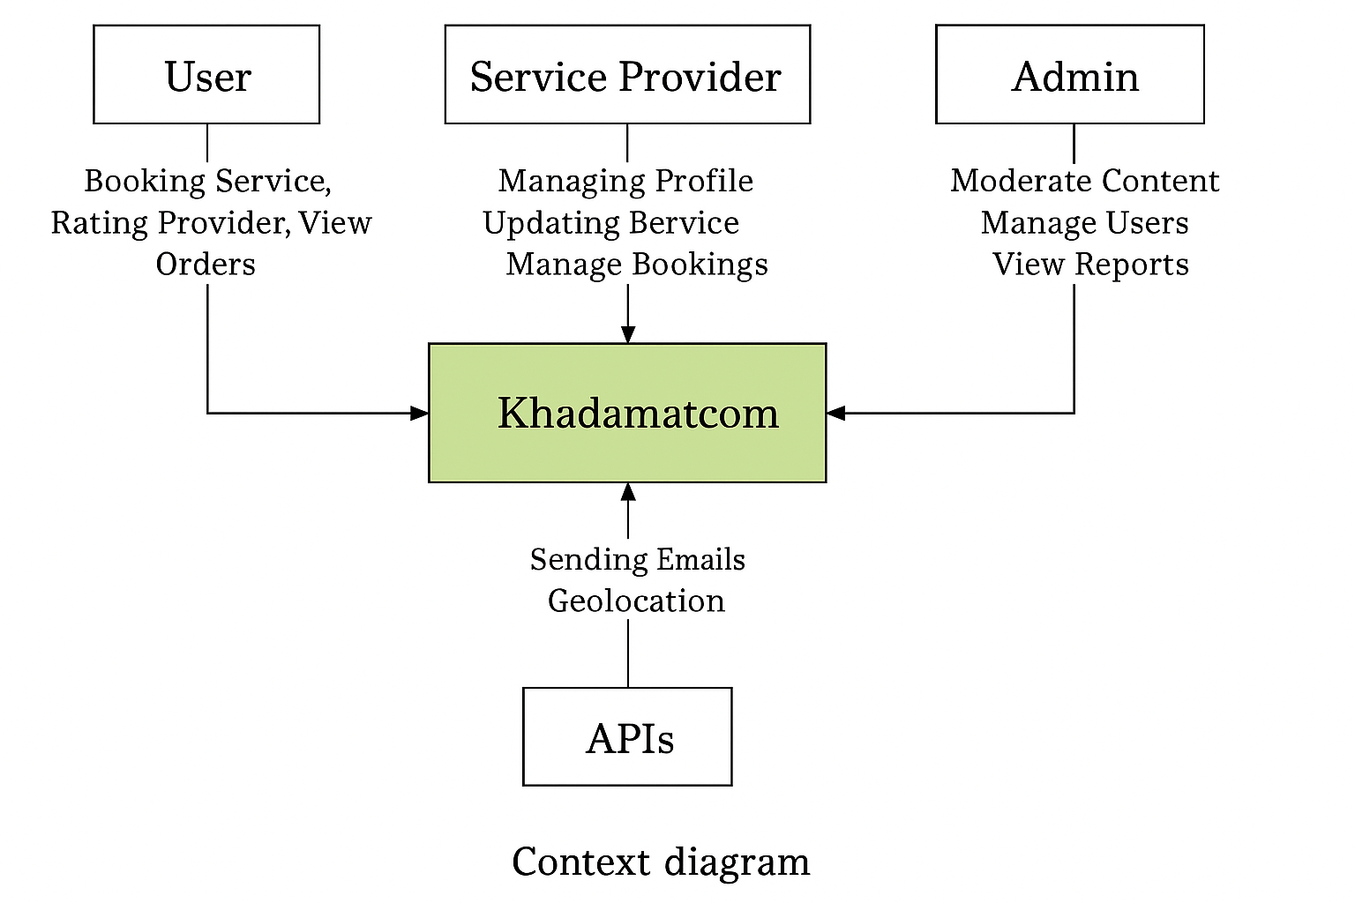
Figure 11 : Context Diagram

6.3 Data Flow Diagrams

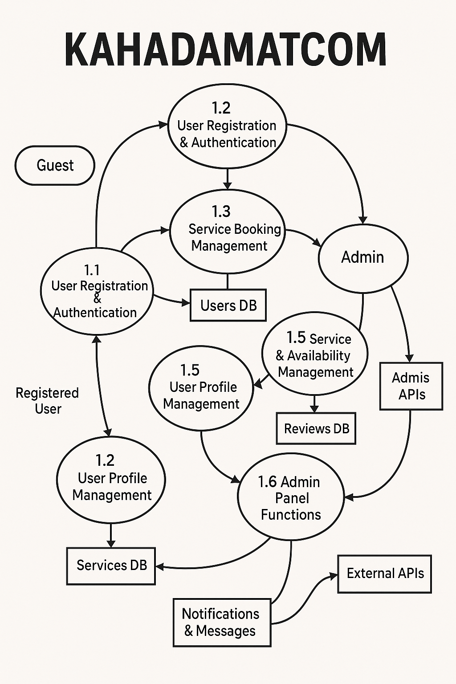
Figure 12:Data Flow Diagrams

6.4 Entity Relationship Diagram

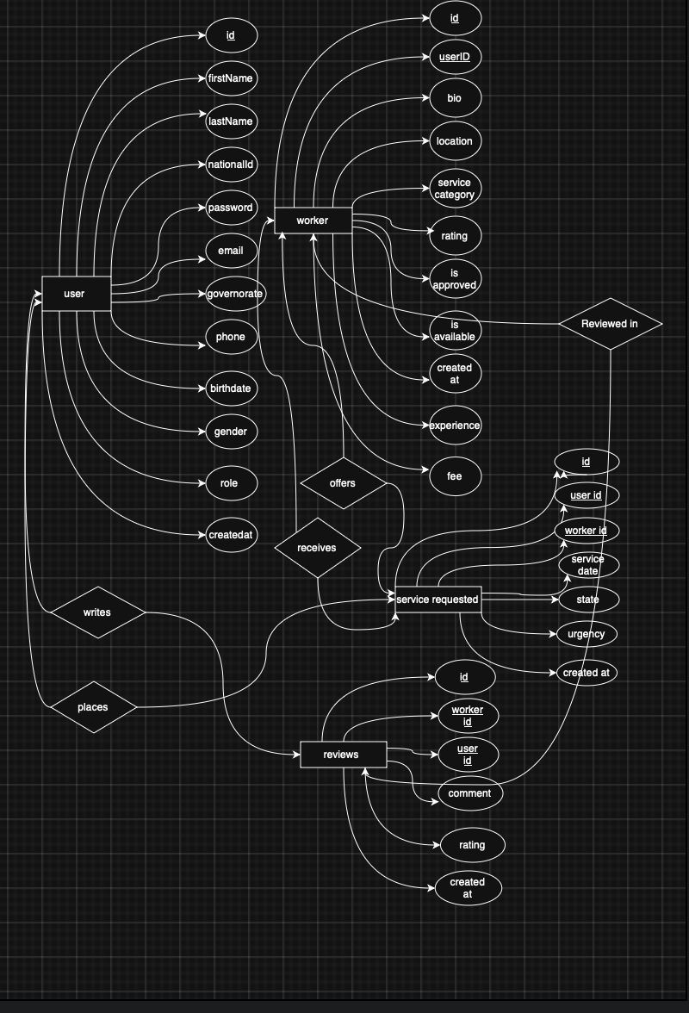
Figure 13: Entity Relationship Diagram

6.5 UML Use Case Diagrams
UML use case diagram 1: use case diagram for entire Next chapter system

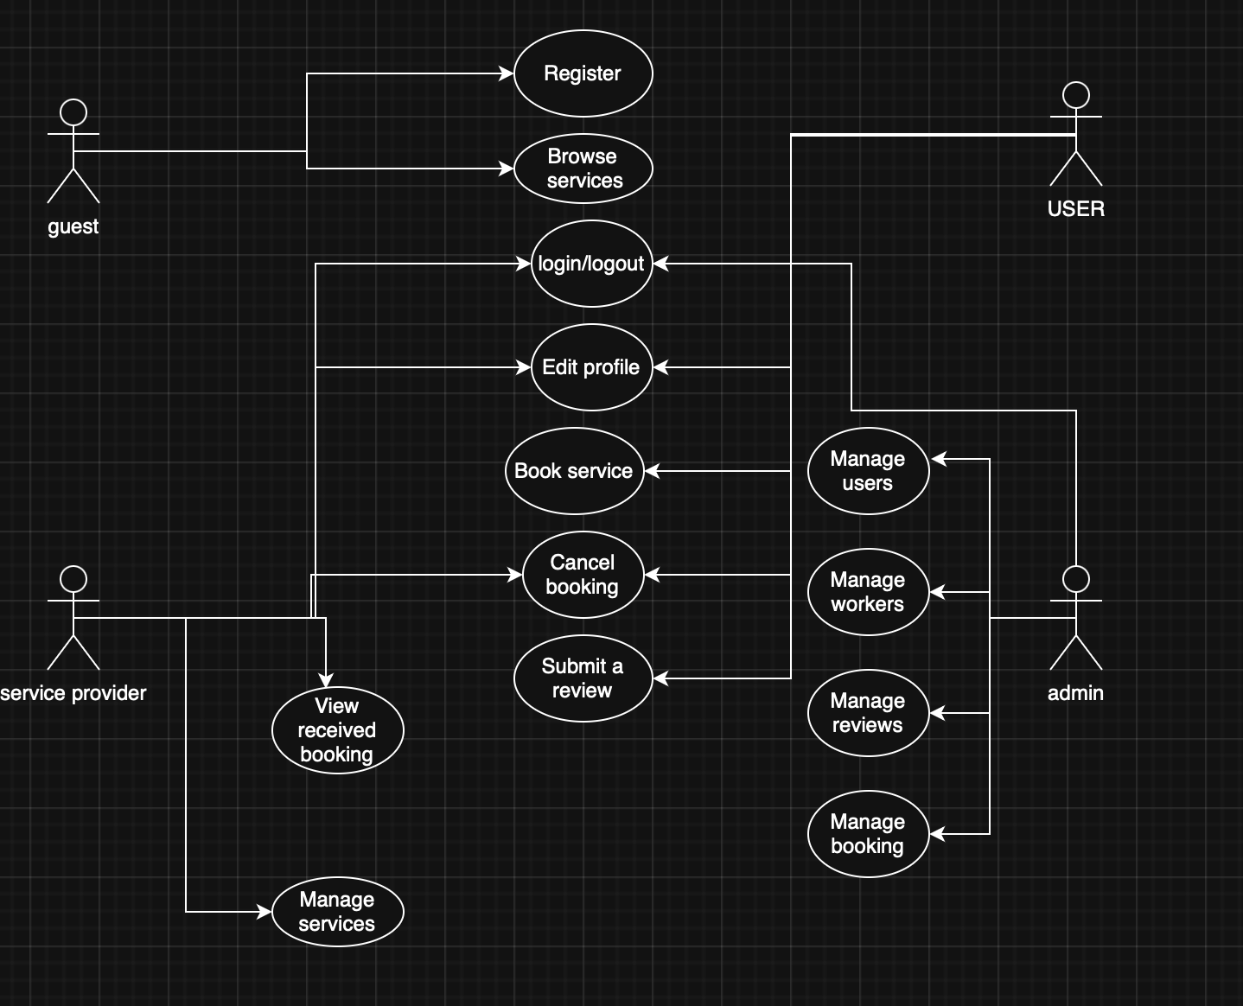
Figure 14: UML use case diagram

UML use case diagram 2: General Overview Diagram (High-Level)

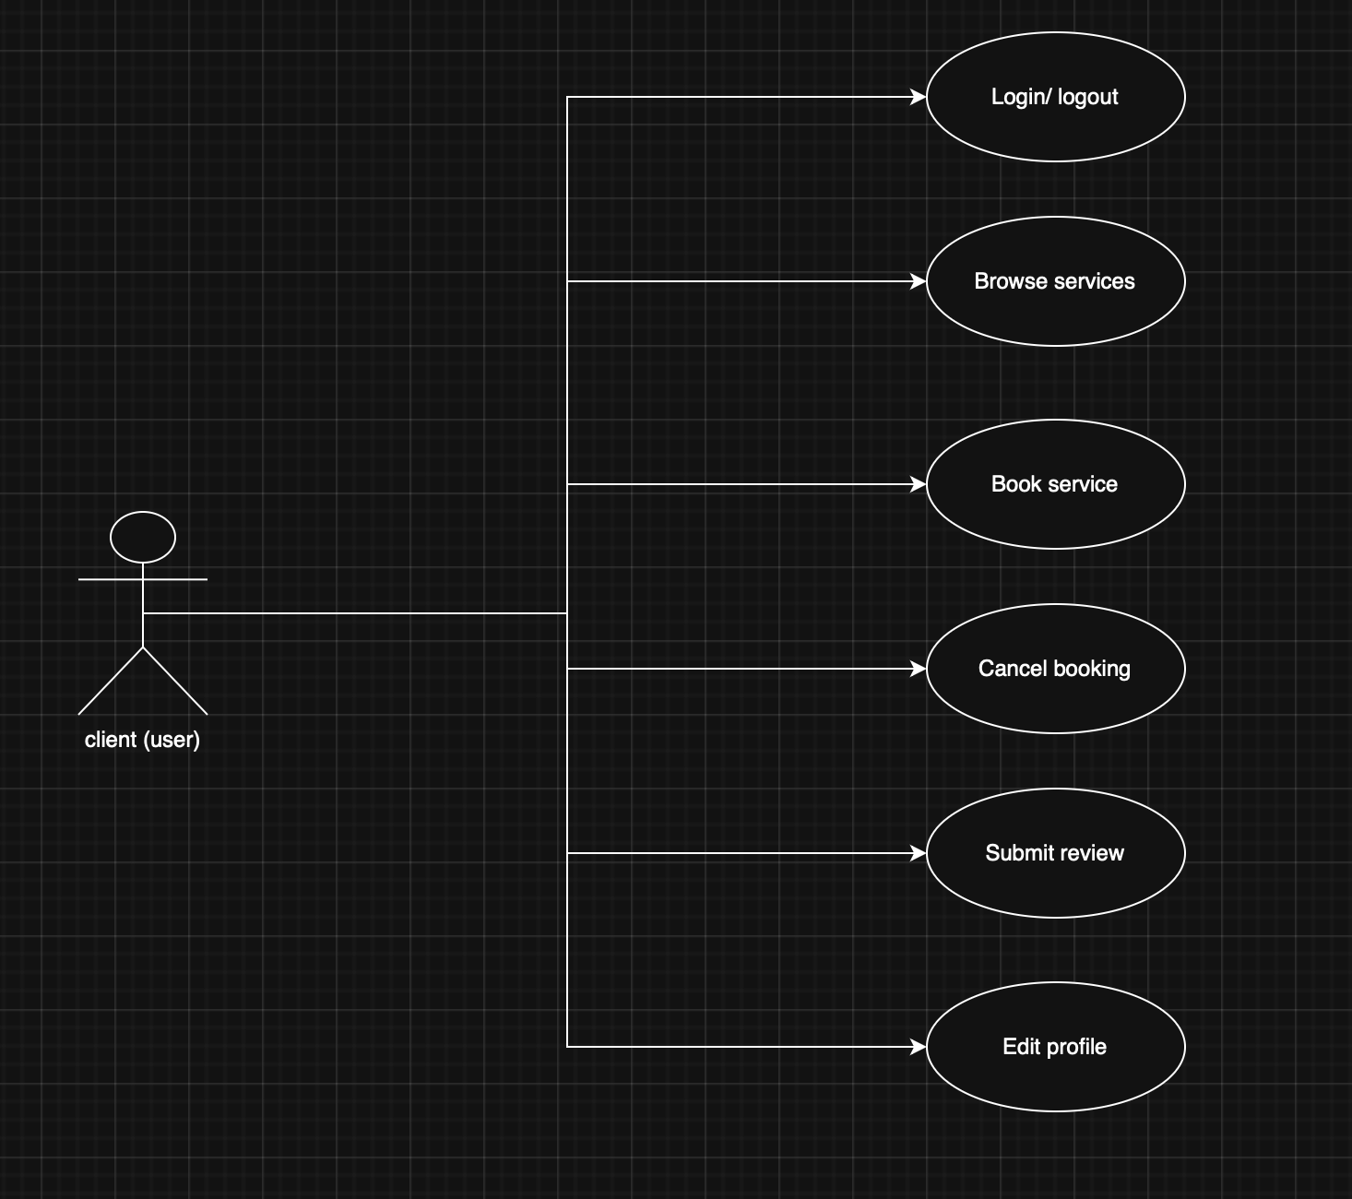
Figure 15: UML use case diagram 2.1
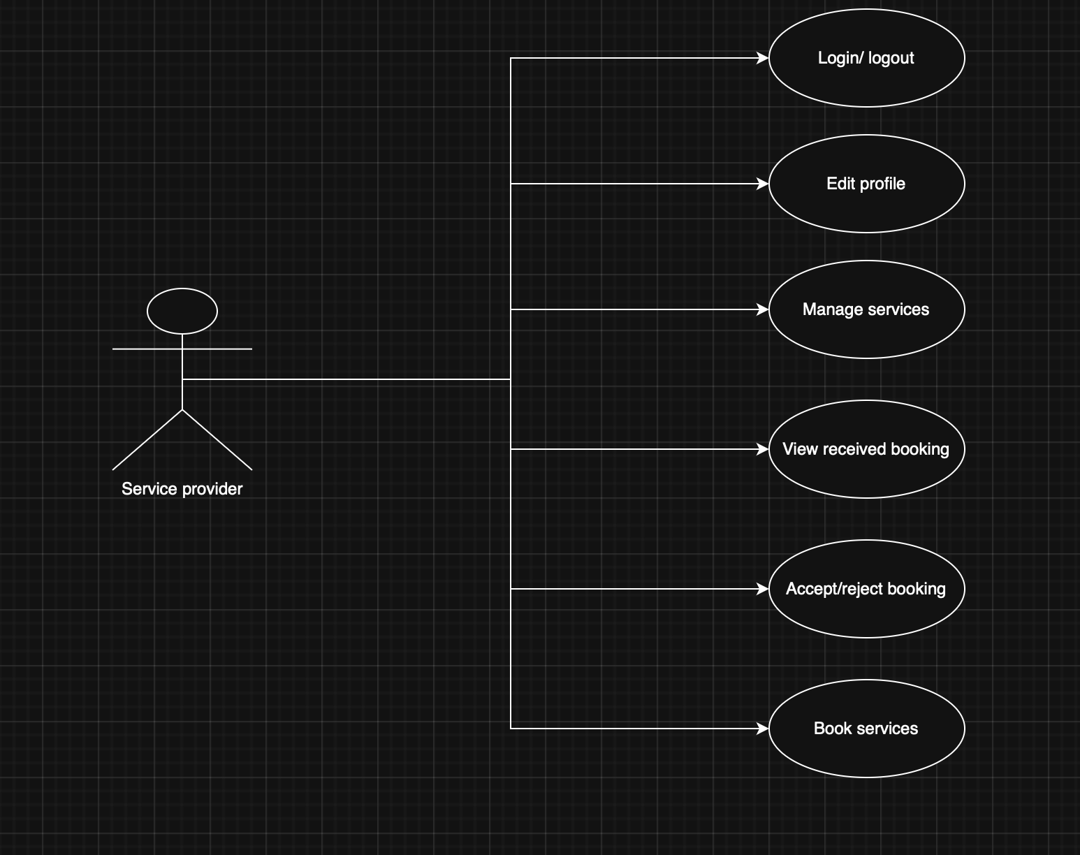
Figure 16:UML use case diagram 2.2

Figure 17: UML use case diagram 2.3

Sequence Diagram 1: Login
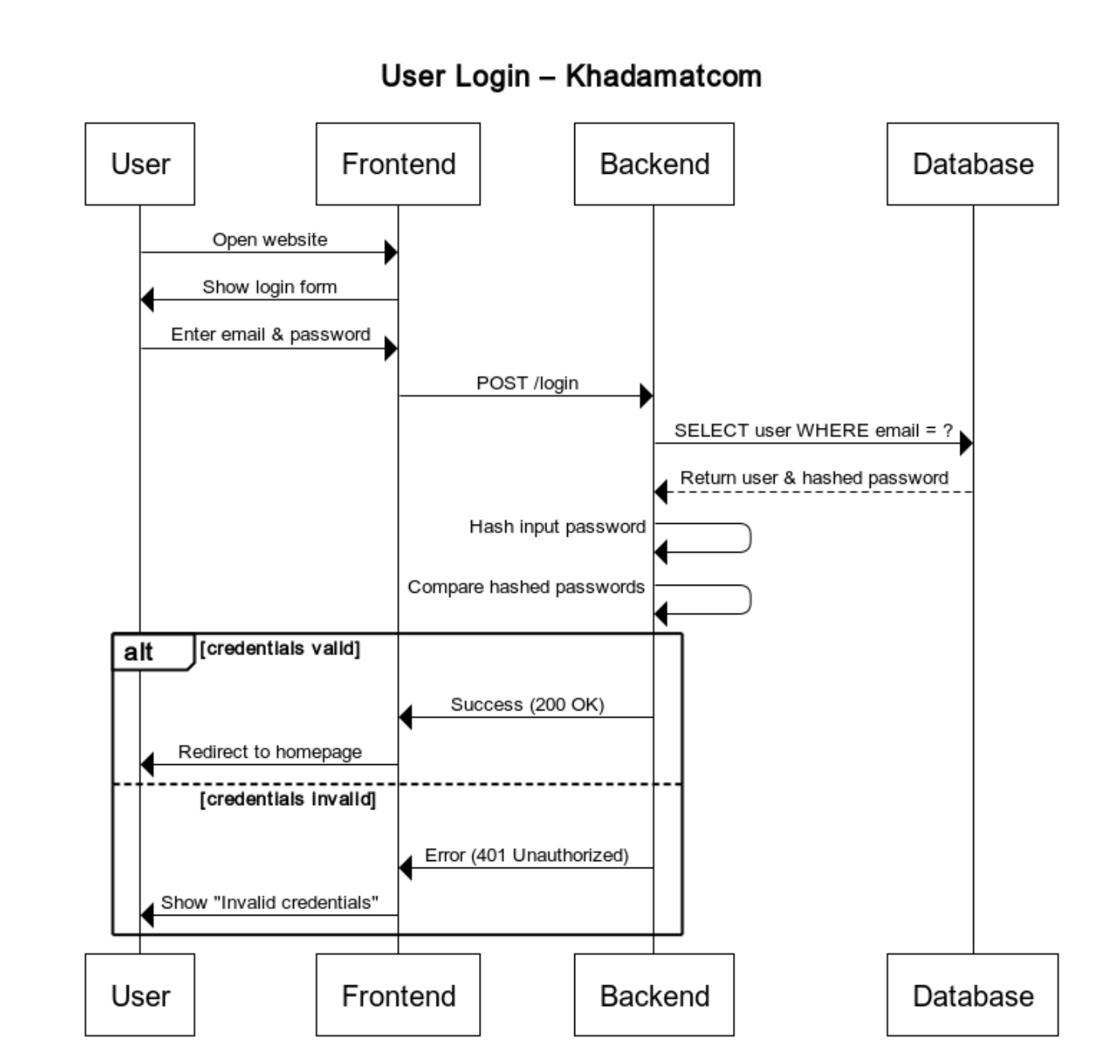
Figure 18:Sequence Diagram 1 : Login

Sequence Diagram 2: registering new account

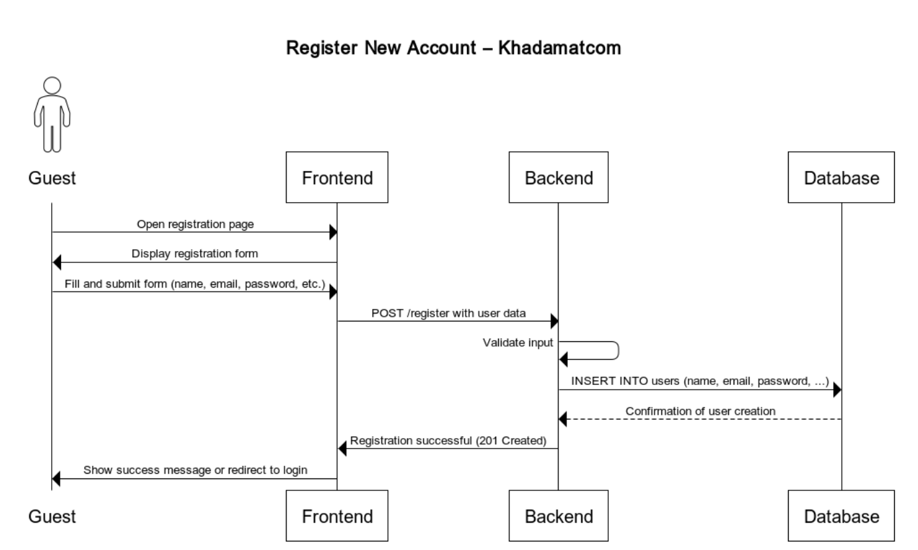
Figure 19: Sequence Diagram 2: registering new account
Sequence Diagram 3: cancel booking

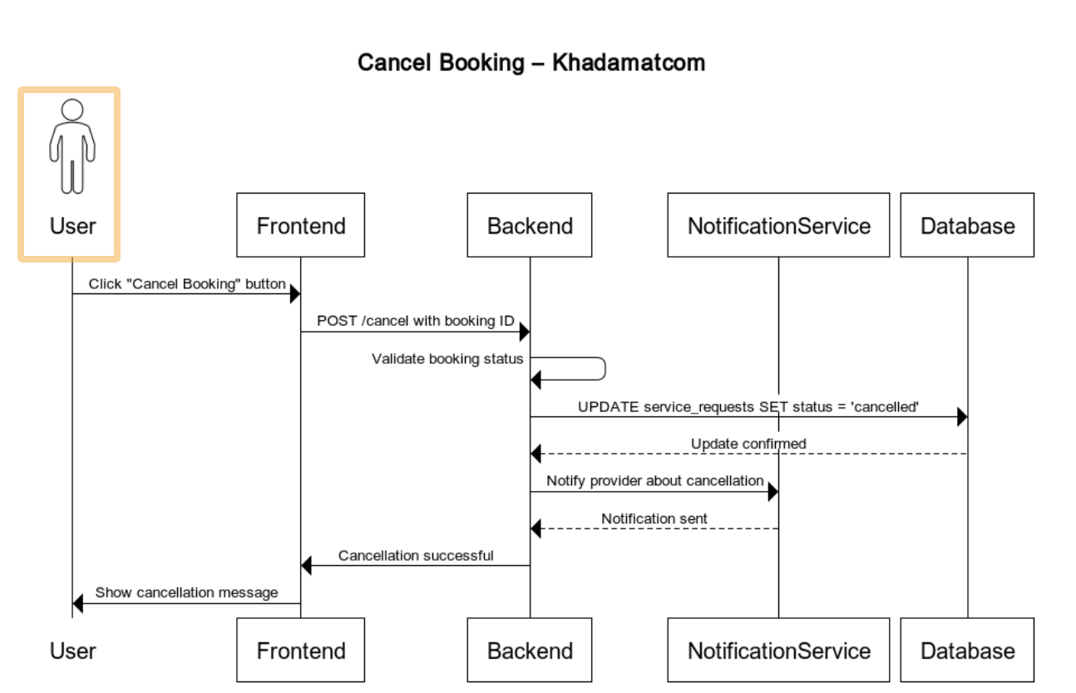
Figure 20 : Sequence Diagram 3: cancel booking

Sequence Diagram 4: access homepage
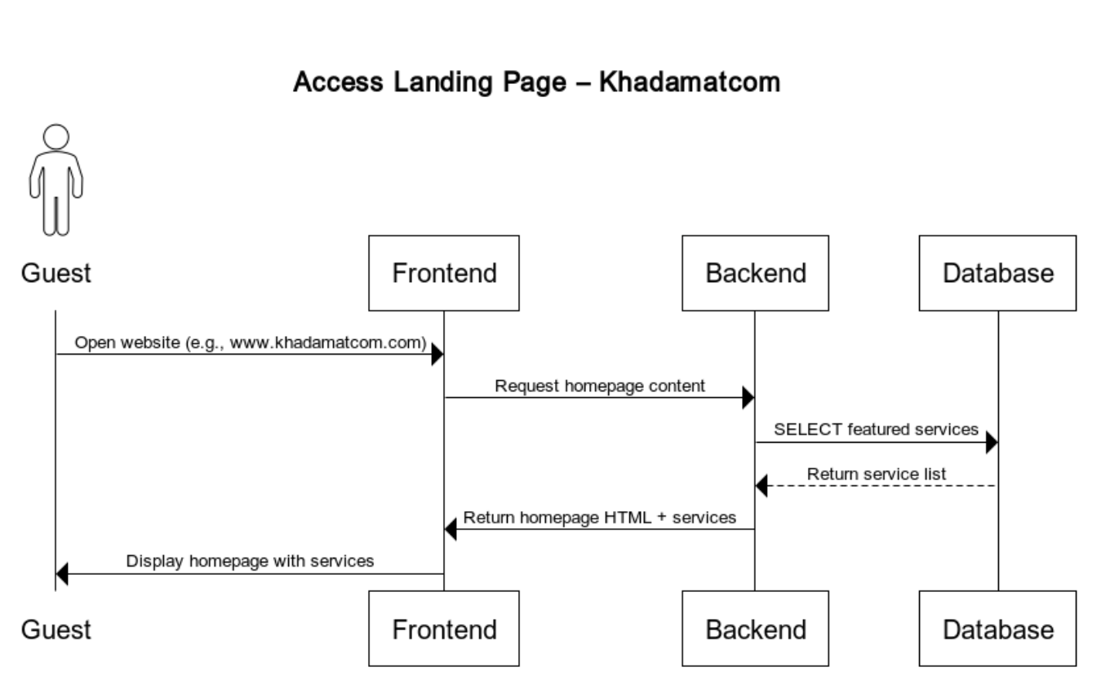
Figure 21: Sequence Diagram 4: access homepage
Sequence Diagram 5: book a service
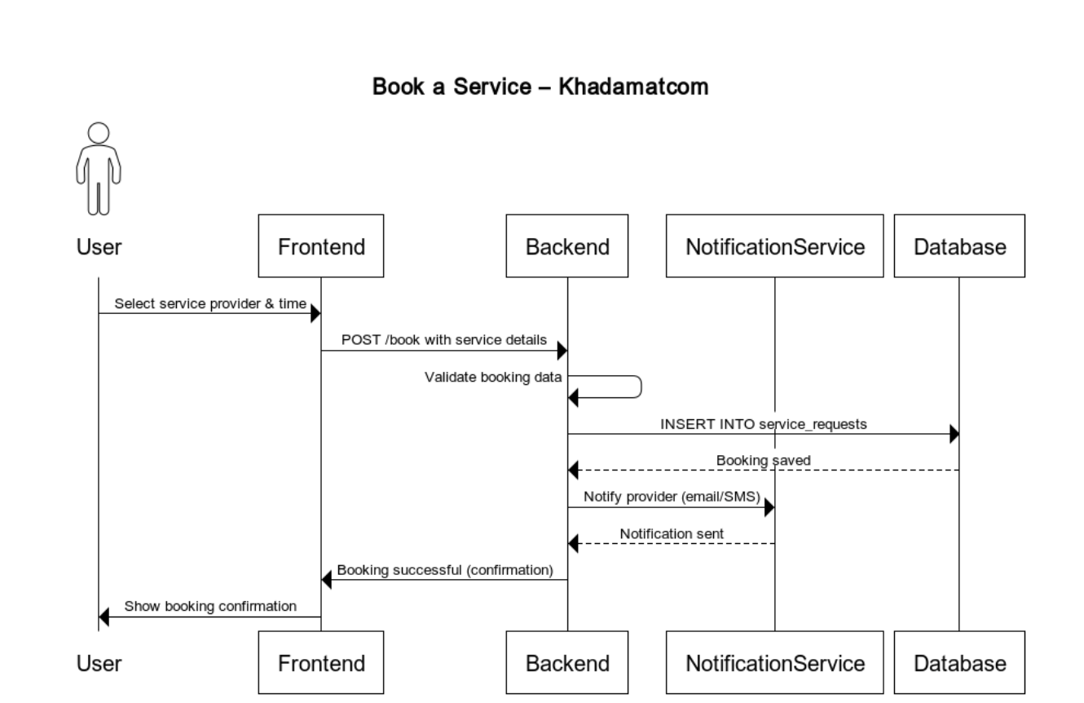
Figure 22 : Sequence Diagram 5: book a service

Sequence Diagram 6: submit a review
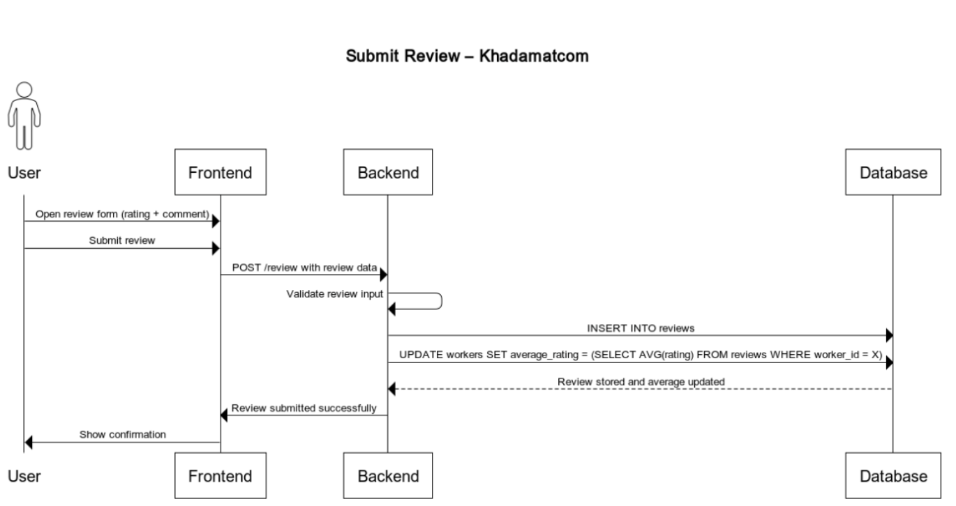
Figure 23 : Sequence Diagram 6: submit a review
Sequence Diagram 7: edit profile

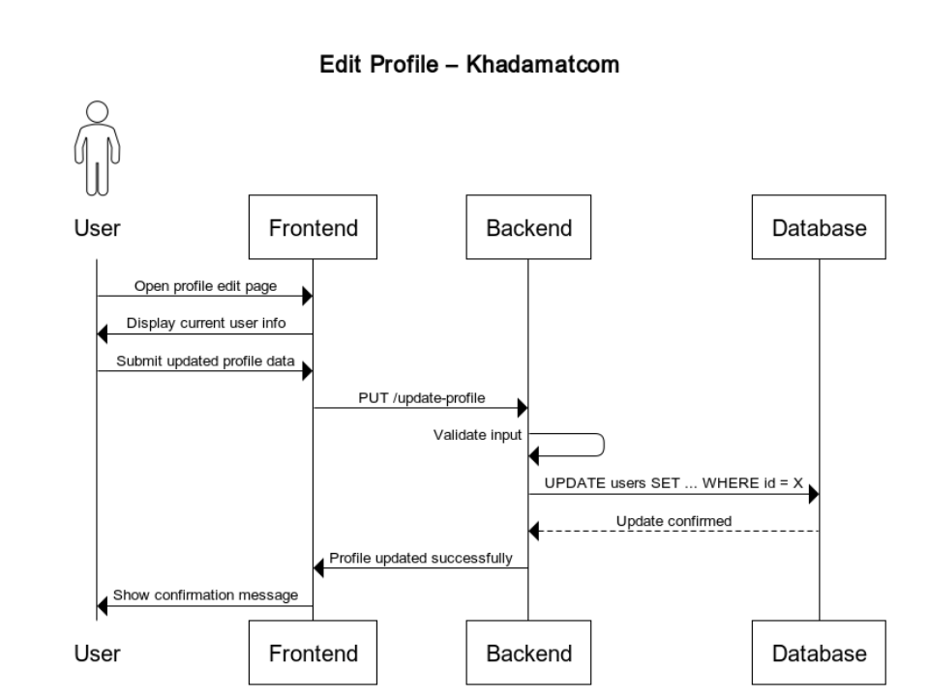
Figure 24 : Sequence Diagram 7: edit profile
Sequence Diagram 8: view booking history
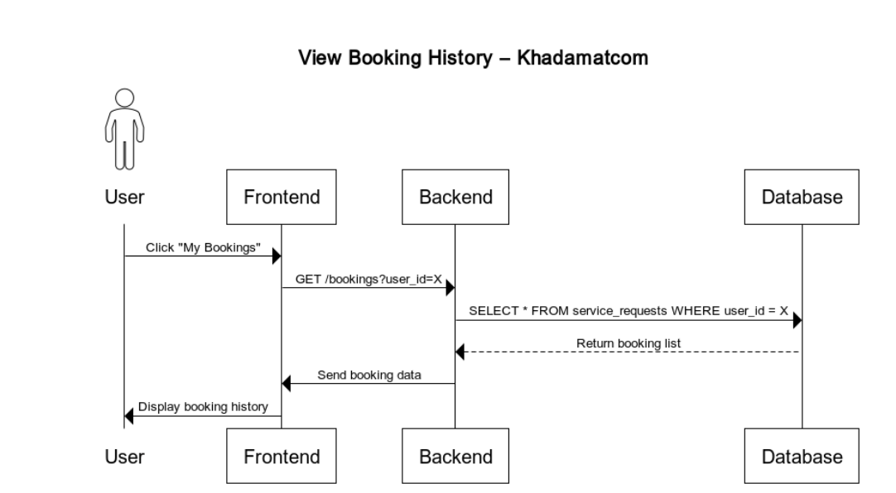
Figure 25 : Sequence Diagram 8: view booking history
Sequence Diagram 9: manage a service
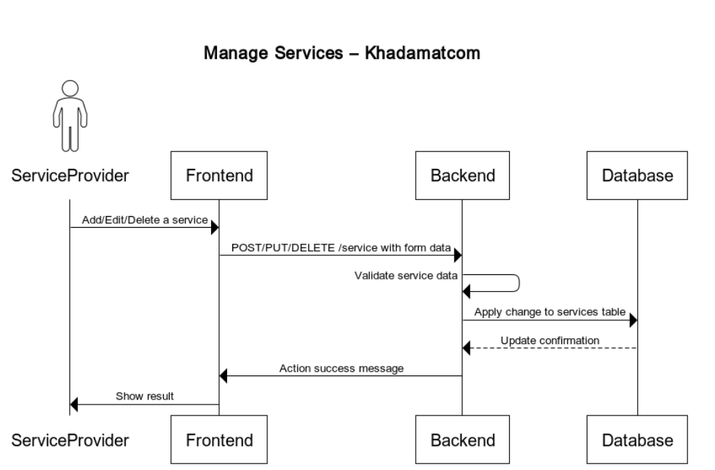
Figure 26 : Sequence Diagram 9: manage a service

Sequence Diagram 10: view received booking
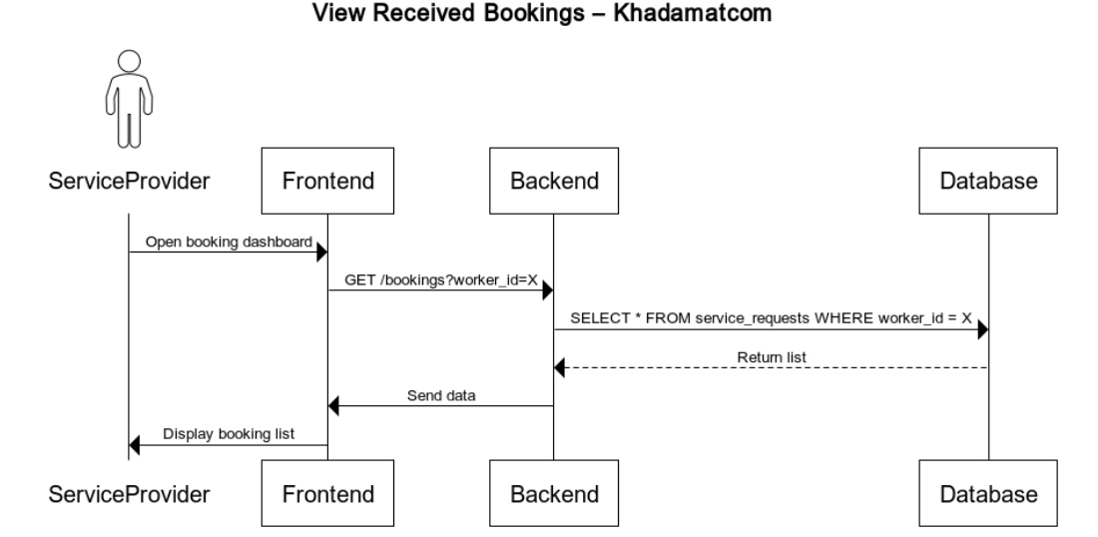
Figure 27 : Sequence Diagram 10: view received booking
Sequence Diagram 11: accept or reject a service
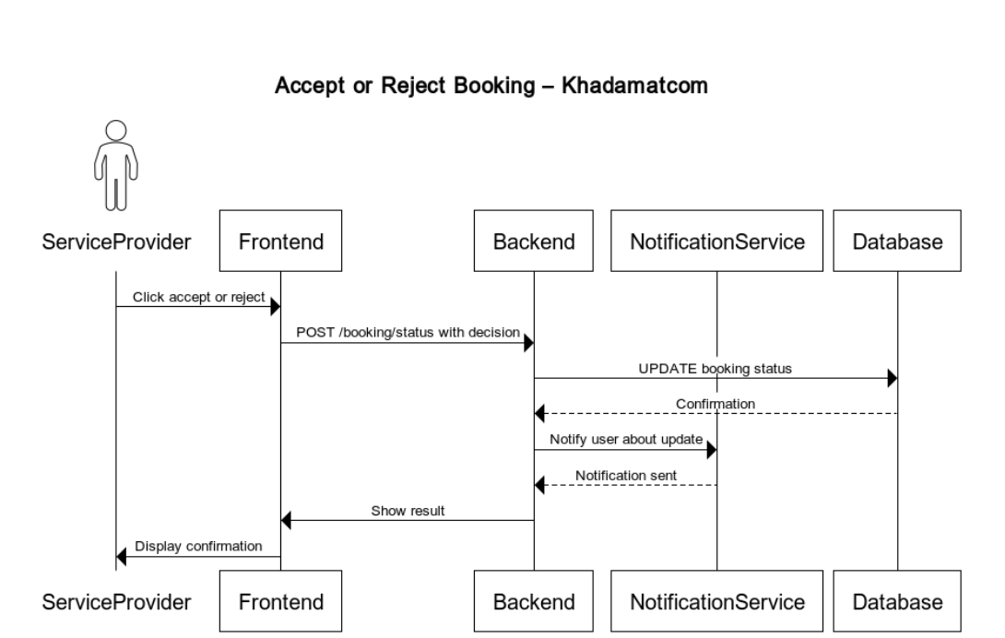
Figure 28 : Sequence Diagram 11: accept or reject a service

Sequence Diagram 12: edit a service provider profile
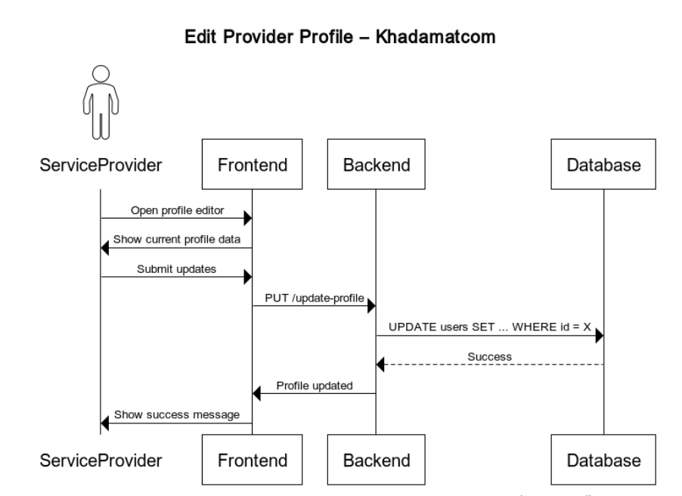
Figure 29: Sequence Diagram 12: edit a service provider profile

Sequence Diagram 13: book another service provider
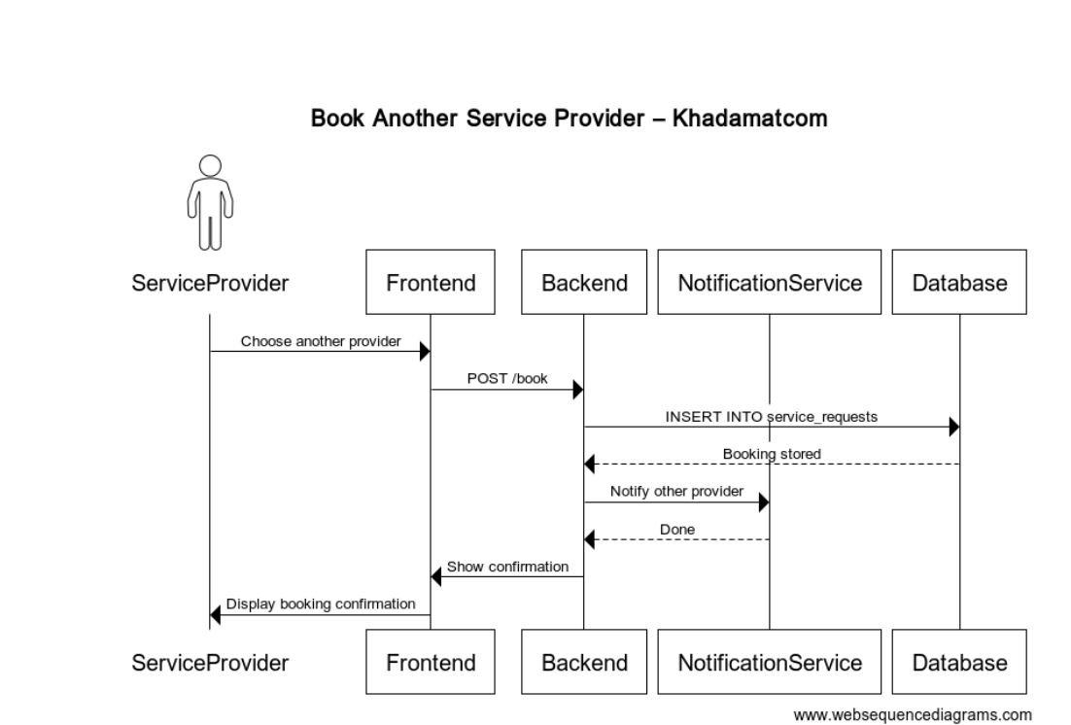
Figure 30 : Sequence Diagram 13: book another service provider

Sequence Diagram 14: admin login with role check
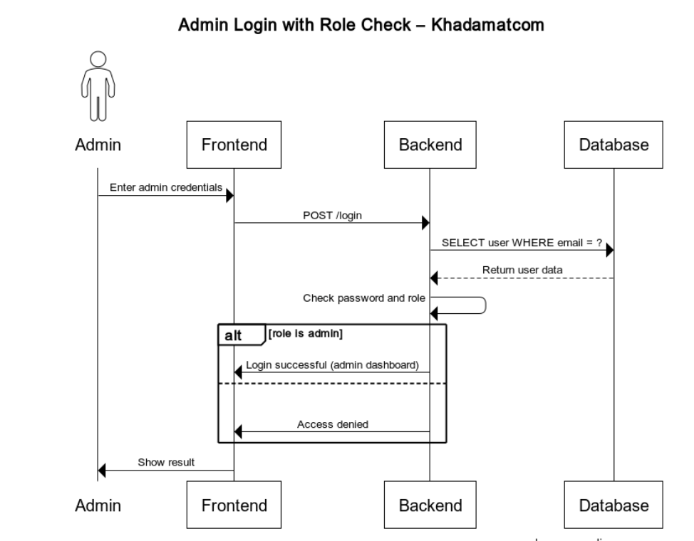
Figure 31 : Sequence Diagram 14: admin login with role check

Sequence Diagram 15: view all users
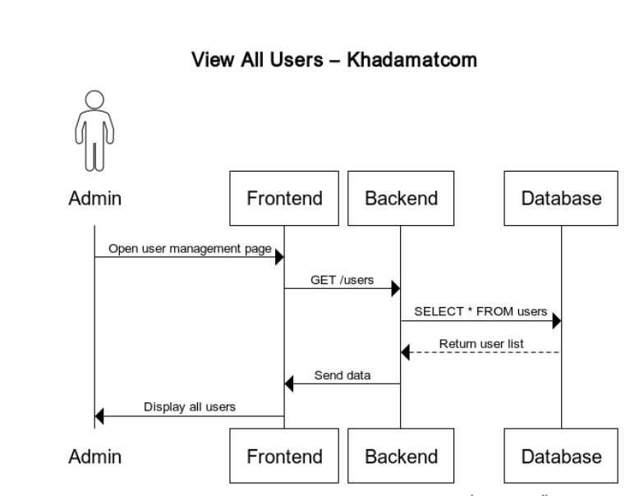
Figure 32 : Sequence Diagram 15: view all users
Sequence Diagram 16: view all service provider
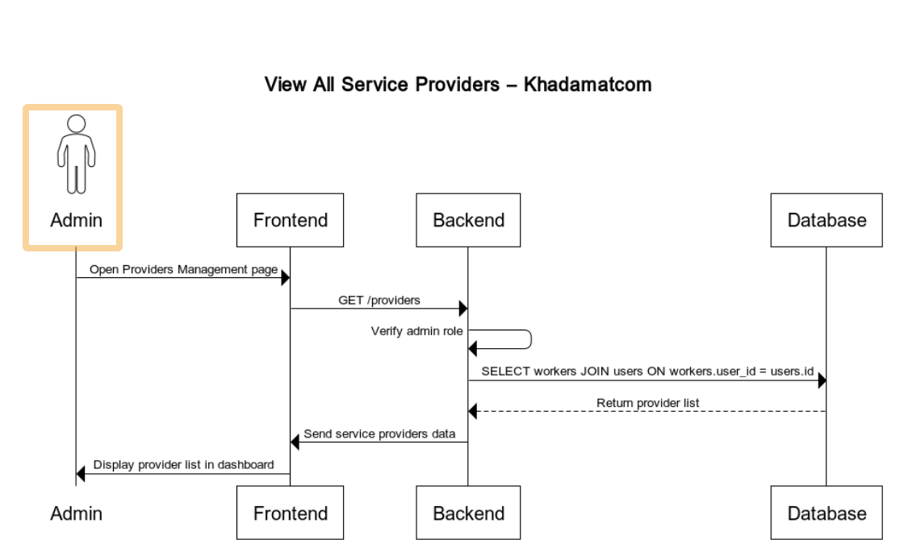
Figure 33 : Sequence Diagram 16: view all service provider

Sequence Diagram 17: view all reviews
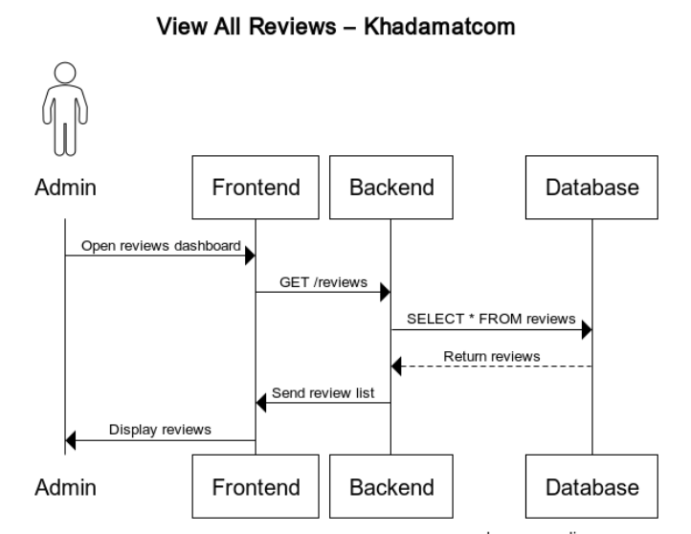
Figure 34 : Sequence Diagram 17: view all reviews
Sequence Diagram 18: delete a review
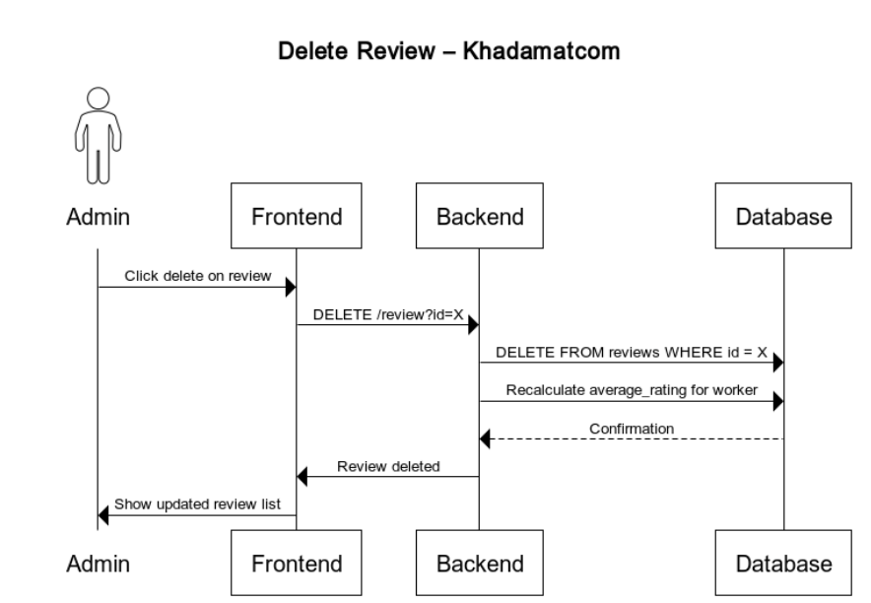
Figure 35 : Sequence Diagram 18: delete a review

Sequence Diagram 19: view all booking
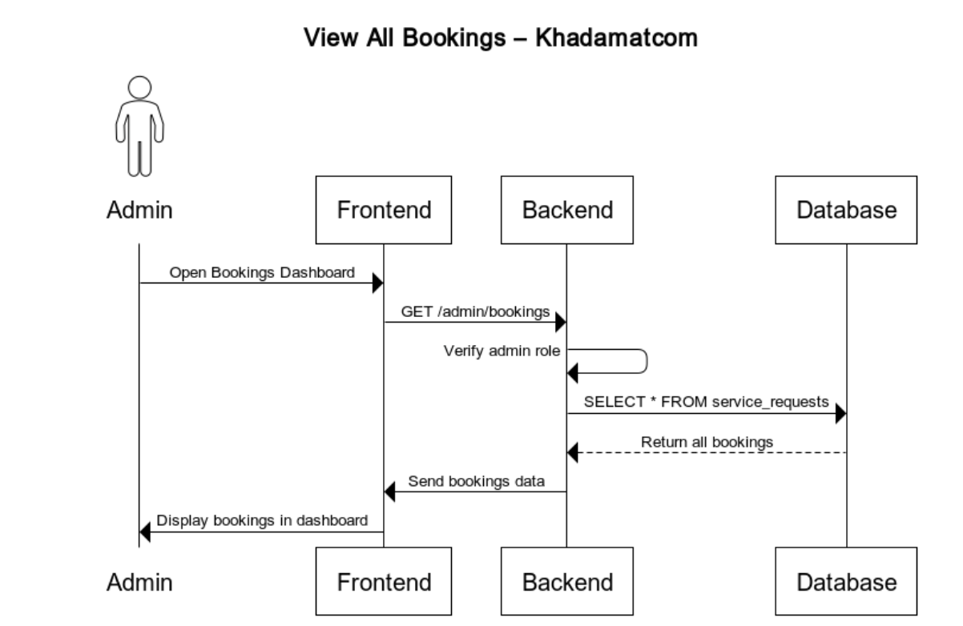
Figure 36 : Sequence Diagram 19: view all booking
Sequence Diagram 20: manage booking
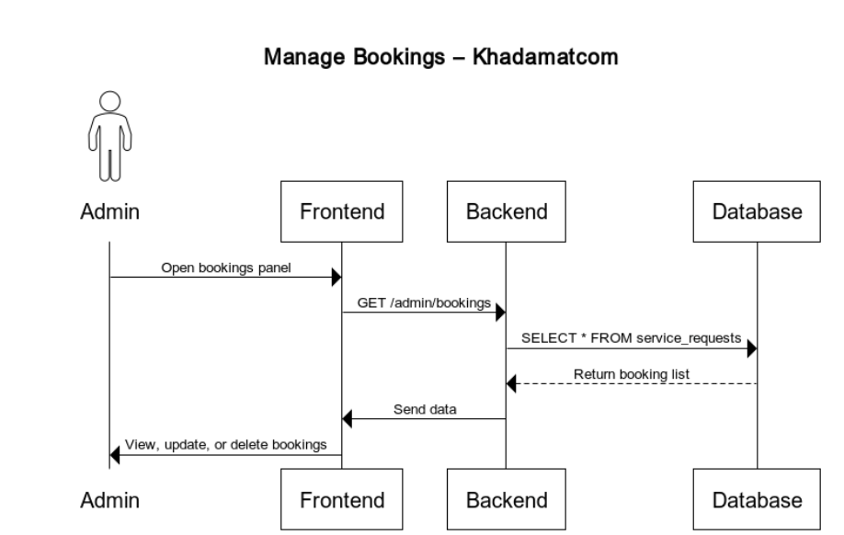
Figure 37 : Sequence Diagram 20: manage booking

6.7 UML Class Diagram
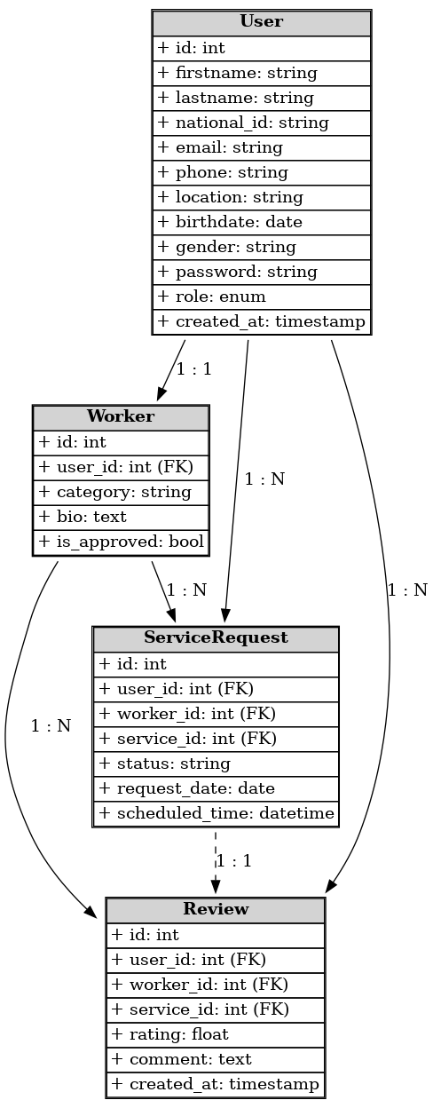
Figure 38 : UML Class Diagram

6.8 Database Design

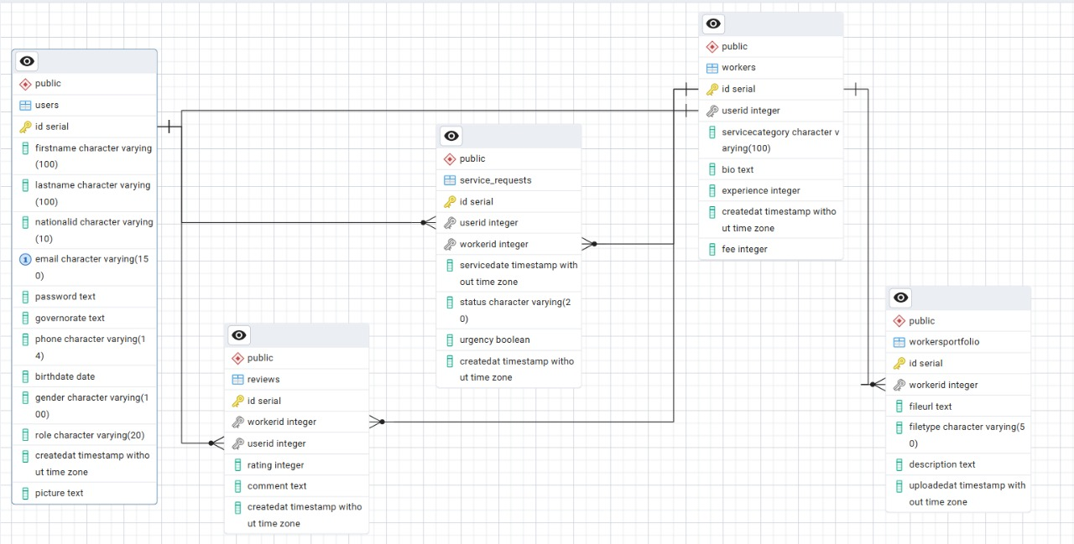
Figure 39 : Database Design
6.9 Kahadamatcom Prototype
Homepage
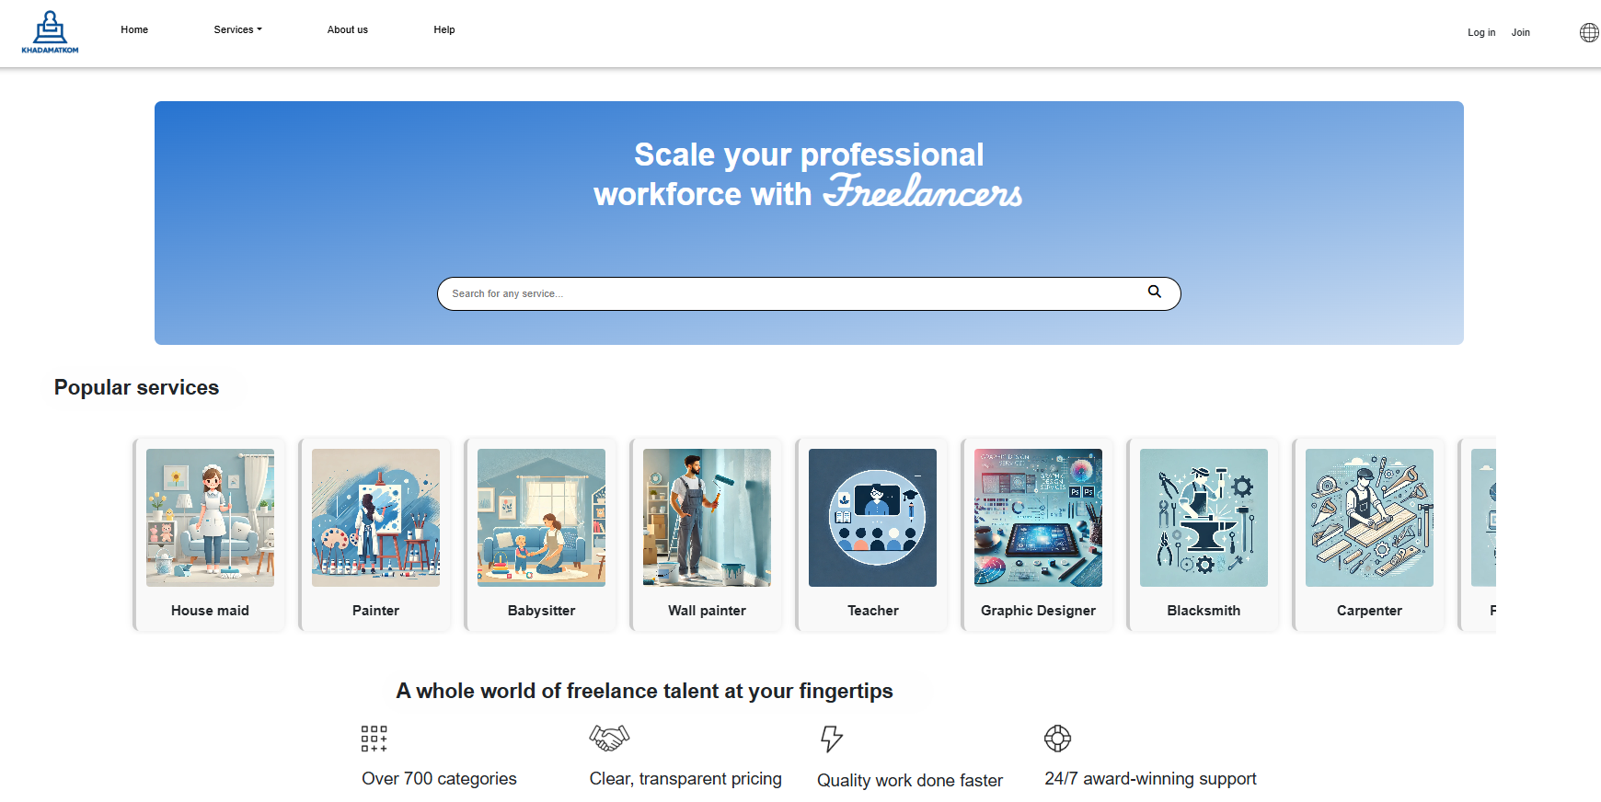
Figure 40 : Prototype for Home Page

Register page:
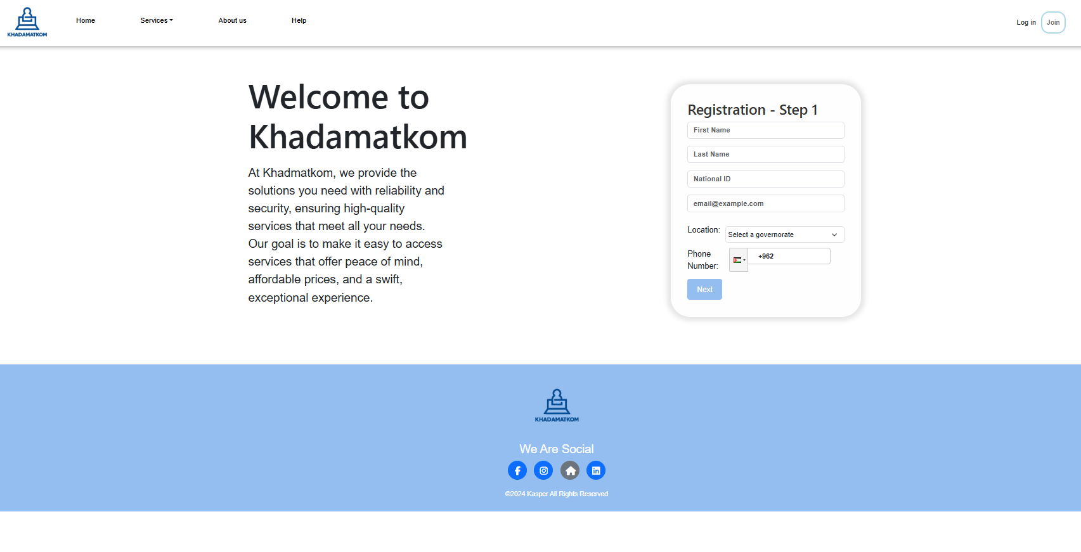
Figure 41 : prototype for Register
Login page:
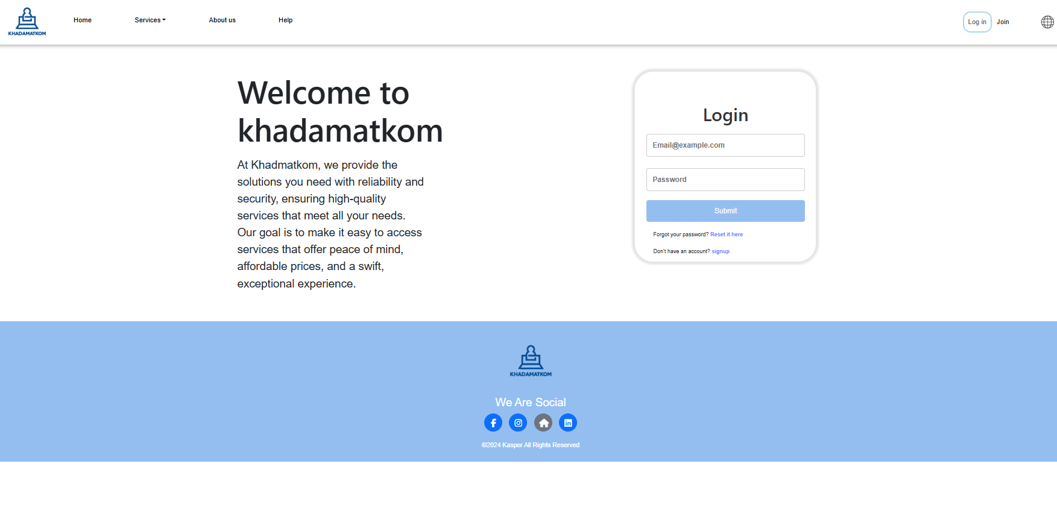
Figure 42 : Prototype for Login Page
Services page:
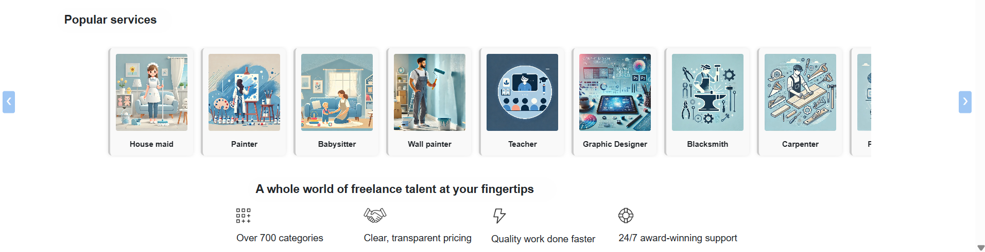
Figure 43 : Prototype for Services page
Profile and profile editing :
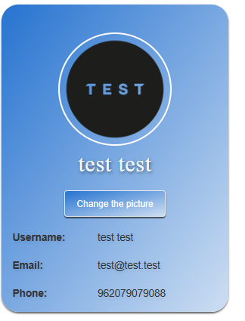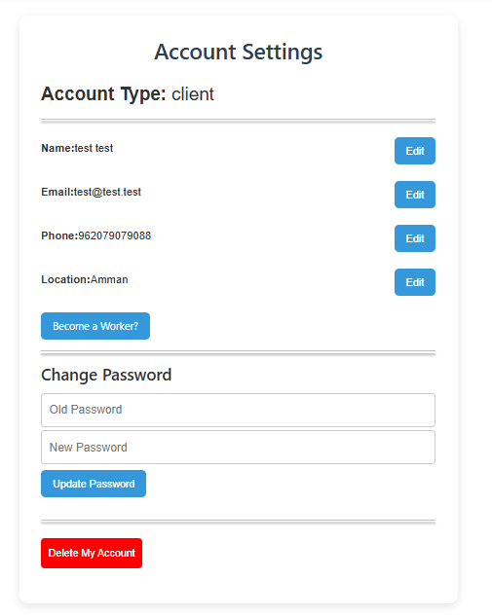
Figure 44: Profile and Profile editing

Services/ requests:
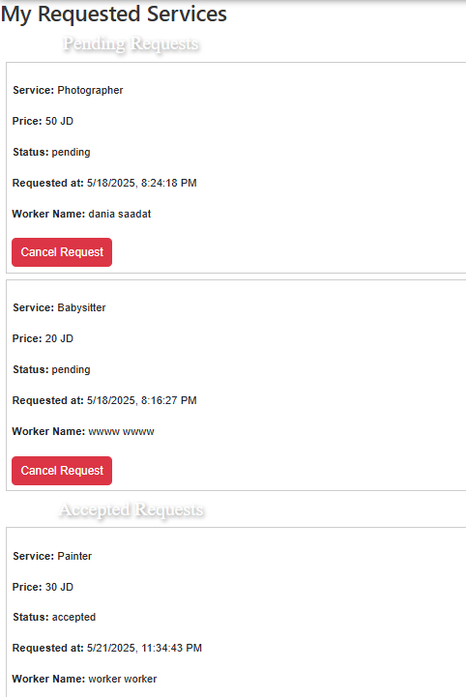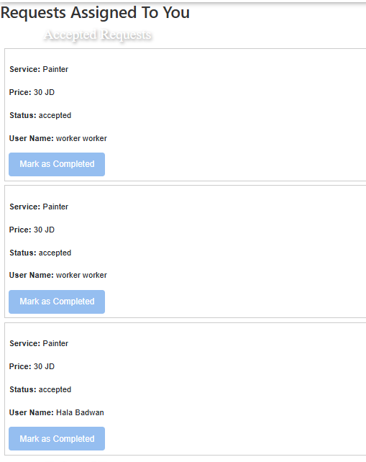
Figure 45 : request Figure 46: Services

Admin dashboard:
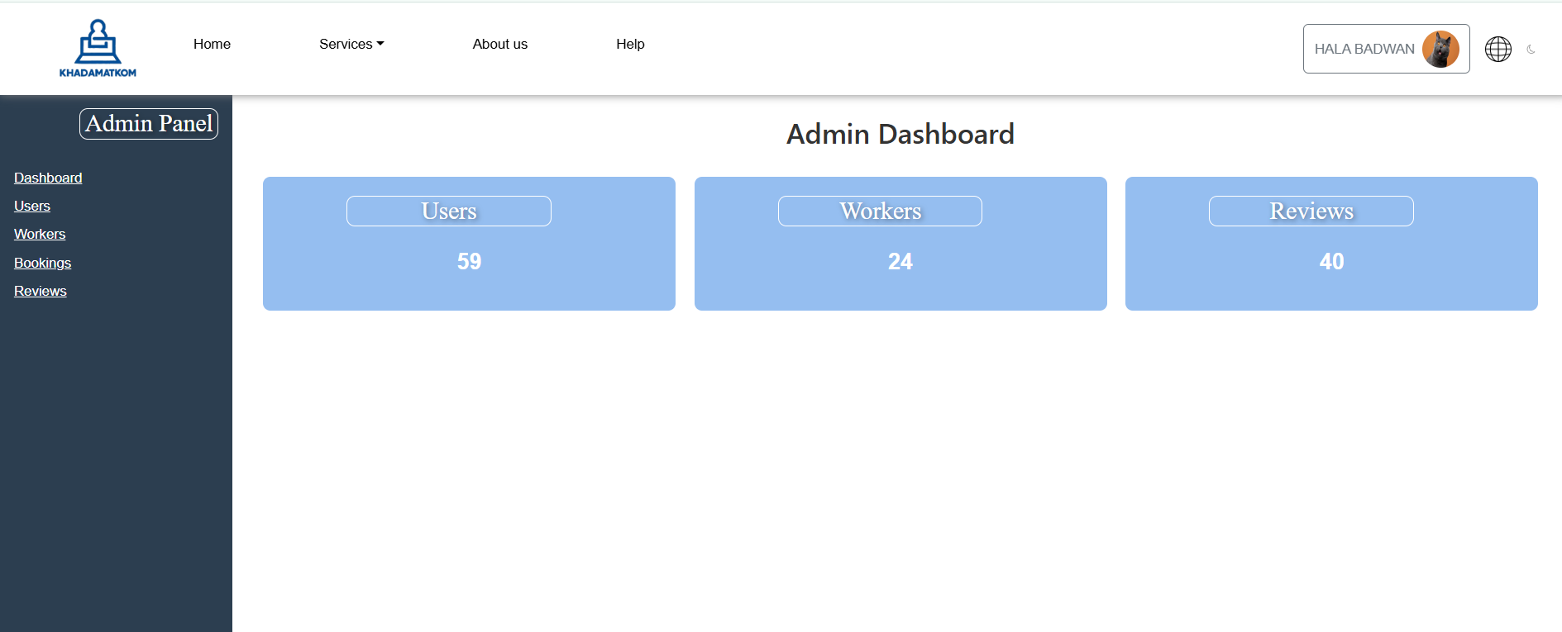
Figure 47: Prototype Admin dashboard

Chapter SEVEN: SYSTEM TESTING AND INSTALLATION

7.0 SYSTEM TESTING AND INSTALLATION
7.1 Introduction
This chapter presents the testing methods and installation procedures used to ensure that the Khadamatcom system functions reliably, is user-friendly, and performs as expected. It outlines the evaluation techniques applied to both interface design and system behavior and concludes with installation instructions and user guidance.

7.2 Heuristic Evaluation
Heuristic evaluation was conducted to assess the usability of the Khadamatcom interface based on Jakob Nielsen’s 10 usability heuristics. Expert evaluators reviewed the system without interacting with real users. Key findings included:
- Visibility of system status: Clear indicators for loading, success, and error messages were found effective.
- Match between system and real-world conventions: Terminology like “Book Service” and “Edit Profile” aligned with user expectations.
- User control and freedom: Undo/Cancel options were implemented in forms such as bookings and reviews.
- Consistency and standards: Navigation and button styles were standardized throughout.
- Error prevention: Validation mechanisms prevented common form entry errors.
- Recommendations included improving the contrast in button colors and providing tooltips for icons.

7.3 Cooperative Evaluation
A cooperative evaluation was performed with real users — including students, service providers, and admin-level testers. Users were asked to complete predefined tasks such as registering, booking services, and managing profiles.
Findings:
- Most users successfully completed tasks without guidance.
- Some users hesitated during the multi-step registration form, so helper text was added.
- Admins found the dashboard intuitive but requested bulk actions for user management.
Changes made based on feedback:
- Added auto-focus and field hints on the registration form.
- Implemented toast notifications for form submissions.
- Grouped admin actions more clearly on the dashboard.

7.4 System Installation
Khadamatcom is a web-based application, and installation involves setting up both the frontend and backend services, along with database configuration.
Backend Requirements:
- Node.js v18+
- PostgreSQL 14+
- Environment file (.env) with database credentials
Frontend Requirements:
- React.
- npm/yarn
Installation Steps:
- Clone the project repositories.
- Run npm install in both frontend and backend folders and dependices .
- Set up the PostgreSQL database and run the provided migration script.
- Launch frontend server with npm start.
- Launch backend with npm Server.js.
Hosting Options:
For deployment, the system is compatible with services like neon.

7.5 User Manual
7.5.1 Introduction
This section guides end users (guests, registered users, service providers, and administrators) on how to use the Khadamatcom platform effectively. It includes system overviews, access instructions, feature walkthroughs, and troubleshooting tips.

7.5.2 System Summary
Khadamatcom is an online service marketplace that connects users with local service providers. The system supports the following roles:
- Guest: Can browse services and register.
- User: Can book services, cancel them, edit their profile, and leave reviews.
- Service Provider: Can manage services, respond to bookings, book other providers, and edit profiles.
- Admin: Can manage users, workers, bookings, and reviews.
The system is accessible on modern browsers (Chrome, Firefox, Safari, Edge) and optimized for mobile and desktop interfaces.

7.5.2.1 Hardware and Software Requirements
To access and use the Khadamatcom platform effectively, users must have the following hardware and software configurations:
- A desktop computer, laptop, tablet, or smartphone with internet access.
- A modern web browser such as Google Chrome, Mozilla Firefox, Safari, or Microsoft Edge.
- An operating system such as Windows 10 or later, macOS, or a recent Linux distribution.
- For administrators and developers, tools like pgAdmin or a PostgreSQL client may be required for advanced database access.

7.5.2.2 User Access Levels
The system defines specific access permissions for each user type to ensure proper authorization and security:
- Regular Users: Can browse available services, book appointments, rate service providers, and manage their own profile information.
- Service Providers: Can manage their profiles, edit their available services, view and manage bookings, and respond to reviews.
- Administrators: Have complete control over the system. They can view all user activity, manage users and providers, moderate reviews, and configure core settings.

7.5.3 Accessing Procedures
Accessing the Khadamatcom platform is straightforward and secure. The process includes:
- Registration: New users can register through the signup form by providing personal information and selecting a secure password.
- Login: Registered users log in using their email address and password.
- Password Recovery: A secure “Forgot Password” option is available for users to reset their password via email authentication.

7.5.4 Main and Advanced Functions
Depending on the user role, different functionalities are available:
- For Users:
  - Browse services by category and location
  - Book appointments
  - View order history
  - Rate and review service providers
- For Service Providers:
  - Add or update service offerings
  - Accept or reject bookings
  - View customer feedback and average rating
  - Update availability and personal information
- For Admins:
  - Access a dashboard to view all users and service providers
  - Block/unblock accounts
  - Monitor review submissions
  - Update global content and configuration settings

7.5.5 Troubleshooting
This section covers common issues users might face and how to resolve them:
- Login Problems:
  - Ensure internet connectivity
  - Double-check email and password
  - Use the password recovery option if needed
- Booking Errors:
  - Confirm that the service is still available at the selected time
  - If issues persist, refresh the page or try again later
- Display/Loading Issues:
  - Clear browser cache and cookies
  - Switch to a different supported browser
  - Ensure browser and system updates are current

7.5.6 Frequently Asked Questions (FAQ)

Q: Can I change my user role after registration?
A: Yes. Users who initially register as regular users can request to become service providers by updating their role in the profile settings. The system will prompt them to fill out the required information (e.g., service type, fee), after which their account will be upgraded to a service provider.
Q: What should I do if I forget my password?
A: Use the “Forgot Password” option on the login page. You’ll receive a secure email link to reset your password.
Q: How is the provider rating calculated?
A: Provider ratings are calculated as the average of all ratings submitted by users. Each review contributes equally to the final score, which is displayed on the provider’s profile.

7.5.7 Glossary
- Booking: A confirmed service appointment requested by a user.
- Service Provider: A user who offers a specific service on the platform.
- Admin Dashboard: A management interface for administrators to monitor and control the system.
- Order: A record of a confirmed service request between a user and provider.
- Category: A classification that groups similar services together.

7.5.8 References
- PostgreSQL Official Documentation
- Node.js and Express.js Documentation
- React.js Documentation
- OWASP Security Best Practices
- GDPR Guidelines and Compliance Resources

7.6 Summary
This section outlined all major user manual components, including system access methods, user roles, main functionalities, and troubleshooting procedures. It serves as a practical reference for all users, from general users to system administrators, ensuring that each can perform their respective tasks efficiently and securely within the Khadamatcom platform.

References
[1] J. Nielsen, Usability Engineering. San Francisco, CA, USA: Morgan Kaufmann, 1994.
[2] J. Nielsen, "10 Usability Heuristics for User Interface Design," Nielsen Norman Group, 1995. [Online]. Available: https://www.nngroup.com/articles/ten-usability-heuristics/
[3] M. Fowler, UML Distilled: A Brief Guide to the Standard Object Modeling Language, 3rd ed. Boston, MA, USA: Addison-Wesley, 2004.
[4] E. Gamma, R. Helm, R. Johnson, and J. Vlissides, Design Patterns: Elements of Reusable Object-Oriented Software. Reading, MA, USA: Addison-Wesley, 1994.
[5] Express.js, "Express - Node.js web application framework," [Online]. Available: https://expressjs.com
[6] PostgreSQL Global Development Group, "PostgreSQL Documentation," [Online]. Available: https://www.postgresql.org/docs/
[7] WebSequenceDiagrams, “Web-Based Sequence Diagram Editor,” [Online]. Available: https://www.websequencediagrams.com
[8] Diagrams.net, “Draw.io - Free Online Diagram Software,” [Online]. Available: https://app.diagrams.net
[9] React.js Team, "React – A JavaScript library for building user interfaces," Meta, [Online]. Available: https://reactjs.org
[10] D. E. Knuth, The Art of Computer Programming, Vol. 1, 3rd ed. Boston, MA, USA: Addison-Wesley, 1997.

Chapter eight: pROJECT CONCLUSIONS AND FUTURE WORK

8.0 PROJECT CONCLUSIONS AND FUTURE WORK

8.1 Introduction
This chapter provides a reflective summary of the outcomes, challenges, and progress achieved throughout the development of the Khadamatkom service management system. It evaluates the system’s overall performance, highlights key strengths and functional accomplishments, and identifies limitations encountered during implementation. Additionally, this chapter outlines potential areas for future development, aiming to improve usability, scalability, and feature richness. The goal is to assess the system’s current capabilities while recognizing practical opportunities for refinement and long-term enhancement.

8.2 Overall Weaknesses

Despite achieving its core objectives, the Khadamatkom system has a number of limitations that could be addressed in future iterations:

Lack of real-time notifications:
The system currently does not support real-time notifications or in-app alerts for key user actions such as request acceptance or review posting. This reduces the immediacy of feedback and user engagement.

Limited activity analytics:
The system does not include built-in tools for tracking user activity, request patterns, or identifying high-demand services and workers, limiting insight into system usage trends.

No built-in messaging or clarification mechanism:
There is no way for users and workers to communicate directly through the system. This can cause delays or misunderstandings in scheduling or request details.

No support for multi-language interface:
The system is currently available in a single language, which may limit accessibility for non-native speakers or diverse user groups.

Manual moderation and limited admin tools:
Admin functions such as user deleting or comment moderation exist, but they lack automation or real-time alerts, which can make managing content slower and less efficient.

8.3 Overall Strengths
The Khadamatkom system demonstrates several core strengths that contribute to its functionality usability, and future scalability:

Role-based access control and secure session handling:
The system clearly defines user roles (guest, customer, worker, admin), and implements session-based access control to ensure users only access appropriate resources.

Clean and intuitive interface using css:
The frontend design prioritizes simplicity and clarity, making it easy to navigate for first-time users on both desktop and mobile devices.

Functional service request workflow:
The core interaction between users and workers through service requests is stable, intuitive, and maintains proper status flow (e.g., pending, accepted, completed).

Responsive review system:
The commenting and review mechanism is user-friendly and provides valuable feedback to workers while enhancing trust among users.

Foundations for future enhancements:
The system architecture supports the addition of real-time features, notifications, and analytics modules without requiring a full redesign.

8.4 Future Work

To enhance the Khadamatkom system and expand its capabilities, several improvements and features are
recommended for future development:

Integrate notification features:
Implement real-time or email-based notifications for key actions such as request status updates, password reset confirmations, and admin messages.

Introduce smart matching and recommendations:
Develop recommendation mechanisms that suggest workers based on user location, past interactions, or service popularity.

Add dark mode and interface customization
Introduce user interface personalization options such as dark mode, adjustable font sizes, and high-contrast themes to enhance visual comfort and accessibility for all users.

Support multi-language interface:
Add multi-language support to allow users to interact with the system in their preferred language, thereby making the platform accessible to a wider and more diverse audience.

Mobile App (iOS & Android):
Launch a cross‐platform mobile app so clients and technicians can request, manage, and track jobs on the go—with a single tap to open the app rather than logging in through a browser. The app will support push notifications for real‐time alerts (e.g., “New job assigned,” “Technician en route,” “Job completed”), ensuring users never miss an important update.

In‐App Chat System:
Implement a built‐in chat feature that allows clients and service providers to exchange text, images, and small attachments directly within each service request. By keeping conversations tied to the relevant job, we eliminate the need for external messaging apps, preserve all chat history in one place, and improve privacy and context.

Online Payment Integration:
Integrate a secure payment gateway that lets clients pay instantly with credit/debit cards, e-wallets, or popular local payment services (e.g., regional bank portals). Automatic invoice generation and receipt issuance will streamline billing workflows—funds post directly to our merchant account, and administrators can reconcile payments without manual tracking.

Emergency Booking Option:
Add a priority booking mode where clients can mark a request as “urgent” (e.g., burst pipe, power outage) to receive same‐day or within‐hours service. Emergency jobs are flagged in the backend queue and broadcast to on‐call technicians first, with an optional surcharge applied automatically so that critical issues get addressed without delay.

